

**KASIT ALUMNI NETWORKING**

**AND MENTORSHIP PLATFORM**

Prof. Hamad Alsawalqa

Saif almuhtaseb 0222887

Salem alnsour 0213371

Zaid Ibrahim 2220274

Omar ElAli 1230052

Mohammad Altaher 0207528

Supervisor - Saif almuhtaseb

Date of start 16/7/2024

Executive Summary: This project aim to develop a web-based platform that connects current students with alumni from KASIT . The users can chat with alumni and university students and companies. And they can find job opportunities . That will aim to improve the quality of alumni and prepare them for the real world.

Table of Contents

1.0 Project Initiation 11

1.1 Project Overview 11

1.2 Problem Definition 11

1.2.1 Problem Statement 11

1.2.2 Issues 11

1.2.3 Objectives for each issue 11

1.2.4 Requirements 11

1.2.5 Constraints 12

1.3 Feasibility Study 12

1.3.1 Technical Feasibility 12

1.3.2 Operational Feasibility 13

1.3.3 Economic Feasibility 14

1.3.4 Schedule Feasibility 16

1.3.5 Legal Feasibility 17

1.4 Recommended Solution and Expected Project Deliverables 18

1.5 Local and Global Impact of the Proposed Solution 18

1.6 Naming Conventions and Definitions 18

2.0 Project Management plan 19

2.1 Project Organization 19

2.2 Roles and Responsibilities 19

2.3 Software Process Model 19

2.4 Tools and Techniques 19

2.5 Work breakdown 19

2.6 Assigning Team Members to Tasks 20

2.7 Project Schedule 21

2.8 Risk Analysis and Plans 21

2.9 Monitoring, Reporting, and Controlling Mechanisms: 24

3.0 Software Requirements Specifications (SRS) 26

3.1System Stakeholders and Requirements Sources 26

3.2 User Requirement Definition 27

3.2.1 User profiles for students, alumni and companies 27

3.2.2 Messaging and chat functionality 27

3.2.3 Event calendar for networking events 28

3.2.4 Job board for internships and job opportunities 28

3.2.5 Mentorship Program Matching 28

3.2.6 users Achievements and News Feed 28

3.2.7 continuous learning 28

3.2.8 successful stories 28

3.4 System Functional Requirement Specification 30

3.4.1 User Registration and Authentication 30

3.4.2 Profile Management 31

3.4.3 Messaging and Communication 31

3.4.5 Job Board 32

3.4.6 Mentorship Program 32

3.4.7 users Achievements and News Feed 32

3.4.8 User Connection Management 33

3.4.9 Administration and Moderation 33

3.5 Textual Description for Each Use Case 34

3.6 Non-Functional Requirements 37

3.6.1 Performance Requirements 37

3.6.2 Dependability Requirements 37

3.6.3 Security Requirements 37

3.6.4 Usability Requirements 37

3.6.5 Operational and Environmental Requirements 38

3.6.6 Maintainability Requirements 38

3.7 Data Requirements 38

3.7.1 User Profiles Data 38

3.7.2 Messaging and Chat Data 38

3.7.3 Event Calendar Data 38

3.7.4 Job Board Data 39

3.7.5Mentorship Program Data 39

3.7.6 users Achievements and News Data 39

3.7.7 Security and Privacy Data 39

3.7.8Analytics and Reporting Data 39

5.0 Implementation 64

5.1 Graphical User Interface Implementation 64

6.0 User Manual 110

7.0 References: books and tools 112

­­

List of Tables

**Table 1 Effort cost ……………………………………………………………………...…….. 9**

**Table 2 Expenses …………………………………….…………………………………...…… 9**

**Table 3 Hardware and Software …………………………………………………..….……… 9**

**Table 4 Operating Costs ………………………………………………………..……..……… 9**

**Table 5 Tangible benefits ……………………………………………………..……….………10**

**Table 6 Payback Analysis 1 ………………………………………………..…….……………10**

**Table 7** **Payback Analysis 2 ……………………………………………..………….….…….. 10**

**Table 8 Tasks breakdown …………………………………..……..…………….…………… 14**

**Table 9 Assigning Tasks …………..……………………………..………...…….…………… 15**

**Table 10 Project Schedule …………..………………………..…………...……….………… 16**

List of figures

**Use case figure**………………………………………………………………………………...24

**1.0 Project Initiation**

**1.1 Project Overview:**

The Alumni Networking & Mentorship Platform is a digital project designed to develop connections between the University of Jordan’s alumni and current students and companies. A place where graduates can meet and greet, exchange ideas, and offer guidance to the new ones.

**1.2 Problem Definition**

**1.2.1 Problem Statement:**

The main problem that faces most of the KASIT alumni is the absence of a networking platform so they can communicate and exchange knowledge and find job opportunities. Also, undergraduate students need guidance from older students .

**1.2.2 Issues:**

* Many alumni struggle to find jobs.
* Students’ lack of guidance.
* Lack of communication among alumni and companies
* The difference between the skills obtained in university and those required by employers

**1.2.3 Objectives for each issue:**

* Creating more jobs for alumni
* To establish a mentorship program
* To create effective communication between alumni and companies by creating networking platforms.
* Bridging the gaps by encouraging strong partnerships with industry leaders to ensure students are workforce ready.

**1.2.4 Requirements:**

Functional requirements:

* User Profiles
* Registration system
* Mentorship Programs
* Chatting Features
* Projects creation and participation
* Job board
* Events organization
* Connection between users
* News feed and achievement

Nonfunctional requirements:

* Usability
* Performance
* Reliability
* Compliance
* Maintainability

**1.2.5 Constraints:**

* Financial restrictions
* Security
* Project deadline
* Reach/Visibility

**1.3 Feasibility Study**

**1.3.1 Technical Feasibility:**

1. Platform Architecture

* Backend: PHP
* Frontend: HTML5, CSS, JavaScript
* Database: MySQL

2. User Authentication and Authorization

* Two factor authentication
* Role-based access control (RBAC) to differentiate between alumni, students, companies and administrators.

3. User Profiles

Profiles: Allow users to create detailed profiles with information such as education, work experience, projects, and skills.

4. Communication Tools

Messaging: general chat between alumni and students and companies.

Also, private chat between any two of them.

5. Networking Features

Events : Create discussion forums and groups for specific interests or industries to facilitate community engagement.

Resources: Provide a section for sharing resources such as articles and learning material.

job postings: companies can offer job opportunities

**1.3.2 Operational Feasibility:**

* Program Design and Structure

Objectives: the main purpose is career advancement, skill development, industry insights, or personal growth.

Resources: One of the best options to enable both mentors and mentees to have the best possible interactions would be to develop learning materials that would facilitate their learning.

* 2. Stakeholder Involvement

Alumni Engagement: You can get students' feedback conveniently and easily by finding out if they are interested in joining the program as alumni mentors. For example, asking alumni

Student/Alumni Needs: Identify student and alumni expectations and needs to fine-tune the success of the program.

Companies Engagement: Provide companies with a platform to offer new job opportunities for students and/or alumni.

* 3. Technology and Infrastructure

Platform Selection: A suitable tool for the efficient running of the program such as communication, work monitoring. It can be a dedicated mentorship software, alumni networks, or learning management systems.

Data Management: Implement a platform that can collect, store and analyze the data obtained from participation, engagement, and outcomes.

Accessibility: Make sure that the website is user-friendly and easily accessible for all participants regardless of their level of comfort with technology.

Training and Support: Schedule orientation sessions and provide continuous guidance for the mentors by informing them of what is expected of them and developing the necessary skills.

Monitoring and Evaluation: Specify target indicators which enable the tracking of evaluations. Ensure the feedback is regularly collected and the necessary adjustments and improvements are implemented.

Budget: Quantify the costs associated with technology, staffing, training, marketing, and events. List the potential sources of support such as institutional support, grants, alumni donations, or sponsorship programs.

Privacy and Confidentiality: Abide by data protection laws and ensure completeness with participants' personal information confidentiality.

**1.3.3 Economic Feasibility:**

* **Development costs:**

(taken from a sample)

**Table 1: Effort cost**

|  |  |  |  |  |
| --- | --- | --- | --- | --- |
| Number | Employee | Hourly wage | Total work hours | Total cost |
| 1 | System Analyst | 15 | 450 | 6750JD |
| 2 | System Administrator | 10 | 25 | 250JD |
| 3 | Programmer | 20 | 300 | 6000JD |
| 4 | Designer | 15 | 200 | 3000JD |
| 5 | Database Specialist | 25 | 20 | 500JD |
| Total |  |  |  | 17625JD |

**Table 2: Expenses:**

|  |  |  |  |
| --- | --- | --- | --- |
| Expense | Cost per student | Number of trainees | Total cost |
| Training | 1500JD | 2 | 3000JD |

**Table 3: Hardware and Software:**

|  |  |  |
| --- | --- | --- |
| Number | Tool | Cost |
| 1 | Laptops | 3000JD |
| 2 | Server | 1000JD |
| 3 | DBMS | 2000JD |
| 4 | IDE | 400JD |
| Total |  | 6400JD |

**Total Development Costs are 30630JD.**

**Table 4: Operating Costs:**

|  |  |  |
| --- | --- | --- |
| Number | Name | Cost |
| 1 | Domain name (per year) | 10JD |
| 2 | Device maintenance | 1000JD |
| 3 | System Update & Enhancements | 1000JD |
| 4 | Server hosting | 300JD |
| Total |  | 2310JD |

**Table 5: Tangible benefits:**

|  |  |  |
| --- | --- | --- |
| Number | Benefits (1-5 years) | Cost |
| 1 | Decrease number of staff | 1500JD |
| 2 | Decrease paperwork, printing and storage cost | 3500JD |
| 3 | Time saved | 2000JD |
| Total |  | 7000JD |

**Intangible Benefits:**

- Improved employee satisfaction.

- improving data accuracy.

- Help managers make informed decisions about performance and development.

- Reducing the workload of employees inside the Warehouse.

- A well-designed interface which can help system users to easily use

the functionality the system provides.

**Table 6: Payback Analysis 1:**

|  |  |  |  |
| --- | --- | --- | --- |
| Year | Development Cost | Operating Cost | Total cost (JDs) |
| Year 0 | 26665JD | 0 | 26665 |
| Year 1 | 0 | 2310 | 2310 |
| Year 2 | 0 | 2810 | 2810 |
| Year 3 | 0 | 3510 | 3510 |
| Year 4 | 0 | 4510 | 4510 |
| Year 5 |  | 6010 | 6010 |

**Table 7:** **Payback Analysis 2**

|  |  |  |  |  |  |  |
| --- | --- | --- | --- | --- | --- | --- |
| Year | Cost | Benefits | Discount Rate (10%) | Accumulated Cost | Accumulated Benefits | NPV |
| Year 0 | 26665 | 0 | 1 | 26665 | 0 | -26665 |
| Year 1 | 2310 | 16500 | 0.90 | 28744 | 14850 | 12771 |
| Year 2 | 2810 | 25000 | 0.80 | 30992 | 34850 | 16629 |
| Year 3 | 3520 | 45000 | 0.70 | 33449 | 66350 | 49530 |
| Year 4 | 4510 | 70000 | 0.60 | 36155 | 108350 | 121725 |
| Year 5 | 6010 | 77000 | 0.50 | 39160 | 146850 | 229415 |

(change discount rate or remove)

Since the present value of accumulated benefits in the third year of operation

(55910) exceeds the present value of the accumulated costs (36884.4), this project has a payback period of slightly less than five (5) years.

- Payback Year = The third Year

- Lifetime ROI = (estimated lifetime benefits - estimated lifetime costs) /

estimated lifetime cost = (233500 - 45815) / 45815 = 4.09

- Annual ROI = Lifetime ROI / Lifetime of The System = 4.09/5 =0.818

- Net Present Value = Total Present value of benefits – Total Present value

of costs = 146850 - 39160 = 107690

**1.3.4 Schedule Feasibility:**

1. Project Planning Phase

Initial planning (1 week)

Assessment: Conduct surveys and focus groups to understand the needs and expectations of alumni and current students.

Benchmarking: Research similar programs at other institutions to gather best practices and insights.

Goal Setting: Define the program’s objectives, target audience

2. Development Phase

Program Design (3 weeks)

Structure: Define the program format, including mentorship matching criteria, communication channels, and meeting frequency.

Resources: Develop training materials, guides, and resources for mentors and mentees.

Platform Selection: Evaluate and select a technology platform for managing the program.

3. Full-Scale Launch Phase(1 week)

Support Services: Offer continuous support and resources to participants, including regular check-ins and troubleshooting.

Community Building: Foster a sense of community through events, and networking opportunities.

4. Sustainability Phase

Monitoring and Evaluation (Continuous)

Regular Assessment: Continuously monitor program metrics and collect feedback to ensure ongoing improvement.

Annual Review: Conduct a comprehensive annual review of the program to assess its impact and make strategic adjustments.

Long-Term Strategy: Create a long-term strategy for sustaining and growing the program, including securing ongoing funding and resources.

**1.3.5 Legal Feasibility:**

* Data Privacy and Protection

Data Encryption: Implement encryption for storing and transmitting personal data.

Access Control: Restrict access to personal data to authorized personnel only.

Law and regulations: The project fully abides by regional laws and regulations.

* Participant Agreements

Participation Agreement: Draft clear terms and conditions for program participation, outlining the rights and responsibilities of mentors and mentees.

Code of Conduct: Develop a code of conduct to ensure respectful and professional interactions among participants.

Informed Consent: Obtain informed consent from participants for data collection, use, and sharing within the program.

* Anti-Discrimination and Harassment Policies

Equal Opportunity: Ensure the program adheres to non-discrimination laws and policies, providing equal opportunities to all participants regardless of race, gender, age, or other protected characteristics.

Anti-Harassment Policy: Implement policies to prevent and address harassment within the program.

Reporting Mechanism: Provide a clear process for reporting and addressing incidents of harassment or discrimination.

**1.4 Recommended Solution and Expected Project Deliverables:**

* We expect to create an environment for alumni and students.
* Improving student communication skills.
* Sharing alumni’s experience with undergraduate student .
* Creating more job opportunities and internships.

**1.5 Local and Global Impact of the Proposed Solution :**

Local impact :

* Make graduates able to deal with different work environments.
* Having more skilled undergraduate students.
* creating more community events.
* Knowledge sharing.
* Continuance learning and UpToDate knowledge.

Global Impact:

* Attracting investors and sponsors.
* Good reputation among countries.
* Creating an international learning community with Jordan as its base

**1.6 Naming Conventions and Definitions**

Program Name :: KASIT bridge

Role Names :: alumni || university student || company

Events Names :: chat || events || projects || job opportunities || mentorship || contact ||study || profile || connect || availability

**2.0 Project Management plan**

**2.1 Project Organization :**

Supervisor: Saif almuhtaseb

Zaid Ibrahim , Salem alnsour : technical team

Saif almuhtaseb , Mohammad Altaher , Omar ElAli :document team

**2.2 Roles and Responsibilities:**

Saif almuhtaseb🡪 planning, documentation(chapter 1,2,5,7) , testing

Zaid Ibrahim 🡪 planning ,backend , testing

Omar ElAli🡪 documentation (chapter 1,4)

Mohammad Altaher🡪 documentation (chapter 3,6), testing

Salem alnsour 🡪 planning, frontend, testing

**2.3 Software Process Model:** agile

**2.4 Tools and Techniques:** visual studio code, ampps, apache , mysql, starUML

**2.5 Work breakdown:**

Table 8:tasks breakdown

|  |  |  |  |  |
| --- | --- | --- | --- | --- |
| **Project Tasks** | **Task Description** | **Deliverables and Milestones** | **Resources**  **needed** | **Dependencies and Constraints** |
| **Task1** | Initiation and planning | Choose the main points of the project | * Laptop * Researches | -- |
| **Task 2** | Requirements and Document | Write the most important requirements | Skills: good at documentation | must know every requirement and how to achieve them |
| **Task 3** | Search for available software or tools | found  Software  Or  not | Research internet for the right software | Must be helpful and reliable software  And must meet requirements |
| **Task 4** | Design and implementation | Create a prototype that meet the most important requirements | One for backend  And one for frontend | -- |
| **Task 5** | Testing first prototype | Check If the prototype meet the requirements  If not, we need to rerun task 2 | Testing all of the testcases  For the main points | After finishing implementation  The main points |
| **Task 6** | Design and implement 2 | Designing and implementation the next group of requirements | One for backend  And two for front end | First ,Must approve the first prototype |
| **Task 7** | Acceptance testing | Check if the whole software meets the requirements | Using testing tool to test the software | After finishing implementation |
| **Task 8** | Maintenance | Check that the software need any updates or changes | One to check the performance and the sustainability for the software | -- |

**2.6 Assigning Team Members to Tasks:**

Table 9 Assigning Tasks

|  |  |
| --- | --- |
| **Task1** | **Saif ,Zaid** |
| **Task 2** | **Whole team** |
| **Task 3** | **Salem,** Omar |
| **Task 4** | **Zaid, Salem** |
| **Task 5** | **Omar, Saif** |
| **Task 6** | **Saif, Zaid ,Salem** |
| **Task 7** | **Saif, Zaid ,Salem ,** Mohammad |
| **Task 8** | Mohammad, Omar |

**2.7 Project Schedule:**

Table 10: Project Schedule

|  |  |  |  |  |
| --- | --- | --- | --- | --- |
| Task | Description | Start date | End date | Duration |
| 1 | Information gathering and planning | 10/07/2024 | 14/07/2024 | 4 days |
| 2 | Project planning and structuring | 15/07/2024 | 18/07/2024 | 3 days |
| 3 | Welcome page & registration protocol 1 | 19/07/2024 | 20/07/2024 | 1 day |
| 4 | Design remaining pages | 21/07/2024 | 24/07/2024 | 3 days |
| 5 | Create system design (Star UML) | 27/07/2024 | 30/07/2024 | 3 days |
| 6 | Implement page design | 31/07/2024 | 01/08/2024 | 2 days |
| 7 | Design database and connect it | 02/08/2024 | 04/08/2024 | 2 days |
| 8 | Implement chat functionality | 05/08/2024 | 06/08/2024 | 1 day |
| 9 | Test chat functionality | 07/08/2024 | 09/08/2024 | 2 days |
| 10 | Implement session creation & join functionality | 10/08/2024 | 13/08/2024 | 3 days |
| 11 | Implement website’s entertainment | 14/08/2024 | 17/08/2024 | 3 days |
| 12 | Testing and validation phase | 18/8/2024 | 20/8/2024 | 3 days |
| 13 | Acceptance testing | 21/8/2024 | 22/8/2024 | 2 days |

**2.8 Risk Analysis and Plans:**

Table 11: Risk Analysis and Plans

|  |  |  |  |  |  |
| --- | --- | --- | --- | --- | --- |
| **Risk Description** | **Explanation** | **Risk Type** | **Likelihood** | **Impact** | **Risk rate** |
| Data Privacy Concerns | Risk of personal data being mishandled or leaked. | Compliance | Medium | High | 6 |
| Low Engagement from Alumni | Alumni may not participate actively, reducing program effectiveness. | project | Medium | High | 6 |
| Inadequate Resources for Management | Lack of staff or tools to manage the program effectively. | organizational | Medium | Medium | 4 |
| Negative Feedback or Reputation | Poor experiences can harm the program's reputation. | business | Low | High | 3 |
| Technological Failures | System outages or issues with the platform used for networking. | Technical | Low | High | **3** |
| Legal Liabilities | Potential legal issues arising from mentorship activities. | Compliance | Low | High | **3** |
| Mentor Burnout | Mentors may become overwhelmed if not supported adequately. | Human | Medium | Medium | **4** |
| Unclear Program Objectives | Without clear goals, the program may lack direction and effectiveness. | project | Medium | High | **6** |
| Funding Shortfalls | Insufficient funding can hinder program operations and growth. | Business  (Financial) | Low | High | **3** |
| Security Breaches | Unauthorized access to sensitive information. | technology | High | High | **9** |
| Lack of Diversity in Participation | Limited representation may affect program inclusivity and richness. | project | Medium | Medium | **4** |

**#Note:**Likelihood:Low = 1,Medium=2,High= 3**||**Impact: Low=1, Medium = 2, High = 3

Table 12:risk mitigation plans

|  |  |
| --- | --- |
| Risk type | Mitigation plan |
| Data Privacy Concerns | * Implement strong data protection policies. * Ensure compliance with data privacy regulations (GDPR). * Use secure platforms for data storage and communication. |
| Low Engagement from Alumni | * Create engaging content and networking opportunities. * Regularly solicit feedback to improve the program. |
| Inadequate Resources for Management | * Secure necessary funding and resources before program launch. * Train staff to manage the program efficiently. |
| Negative Feedback or Reputation | * Actively monitor feedback and address concerns promptly. * Communicate success stories and positive outcomes. |
| Technological Failures | * Choose reliable and well-supported technology platforms. * Regularly back up data and have contingency plans in place * Provide technical support for users. |
| Legal Liabilities | * Consult with legal experts to ensure compliance with laws. * Provide liability insurance if needed. |
| Mentor Burnout | * Recognize and appreciate mentors' contributions. |
| Unclear Program Objectives | * Clearly define and communicate program goals and objectives * Regularly review and adjust objectives to align with participant needs. * Ensure all stakeholders understand their role in achieving goals. |
| Funding Shortfalls | * Diversify funding sources (e.g., sponsorships, grants). * Adjust program scope if necessary to align with available resources. |
| Security Breaches | * Implement robust cybersecurity measures. * Regularly update and patch software and systems. * Conduct security audits and training for staff. * Regularly train staff how to deal with various attacks |
| Lack of Diversity in Participation | * Actively promote the program to diverse groups. * Ensure inclusive practices in recruitment and participation. |

**2.9 Monitoring, Reporting, and Controlling Mechanisms:**

Monitoring mechanisms

* Participant Engagement Tracking

Activity Logs: Take advantage of the program platform by defining the pertinent datum, which would include time of provision, message delivery, and a walk-through of the next meeting.

* Feedback Collection

Surveys: Every week, start the process of surveys among both mentors and mentees to collect interesting experiences views and satisfaction degrees.

Reporting Mechanisms

* Regular Reports

Monthly Reports: Produce a chart giving out the details about the attendance rates, involvement metrics, as well as responses and comments on the feedback given.

Quarterly Reviews: Automation has been the primary means to perform complete quarterly reviews that contain activities involved as well as money and risk management updates.

* Dashboards

Real-time Dashboards: Display the figures dynamically on the program platform, thus users will be able to observe the actual metrics, and thus they can remain in touch with executives and stakeholders at all times.

Controlling Mechanisms

* Quality Assurance

Mentorship Quality Checks: On a regular basis, checking up on mentor-student interactions to make sure if they are going the right course and if rules are being observed.

* Risk Management

Risk Register: Obtain hosting of a risk register and set it up on a timely basis, so that you track possible risks, and their mitigation plans.

Incident Response: Creation and implementation of an incident response plan for rapid dealing with cases that occur.

* Budget Control

Financial Monitoring: A monthly assessment of the expense budget of the program will take place to ensure the accuracy of the budget projections.

* Compliance Monitoring

Data Privacy Audits: Bring in independent professionals to regularly monitor the compliance of the firm with the data privacy laws and establish internal rules.

Legal Reviews: This is often misinterpreted by having an unintentional change in employment status, and external promotions may be authorized.

**3.0 Software Requirements Specifications (SRS)**

**3.1System Stakeholders and Requirements Sources**

* **System Stakeholders:**

**1.Student**

Users of our system who would like to have mentorship, connect with others, looking for internships and jobs through our website, being able to talk to the alumni about internships and being part of the mentorship program.

**2. Alumni**

Alumni use the platform to guide and mentor students, post job openings, and stay actively connected with the university, they are interested in building connections with both students and fellow alumni, offering guidance through mentorship and continuing their involvement with the university community.

**3. KASIT Administrators**

The university administrators are responsible for managing user accounts, ensuring that the platform runs smoothly, they want to promote university events through the platform and use data from the platform (like user activity and feedback) to improve the services offered to students and alumni.

**4.companies**

Potential partners who offer student and alumni job and internship opportunities, the availability of talented people and the development of relationships with the institution for future projects will be key goals for them.

* **Requirements Source :**

1. **Interviews and Surveys with Students and Alumni**

Gather information about needs, preferences, and expectations.

**2. University Administration and Faculty Meetings**

The university administration and faculty are involved in making sure the platform aligns with the university's goals, they meet regularly to discuss and review the platform’s development and progress, ensuring it supports the university’s mission and meets the needs of students and alumni.

**3. Workshops with Employers and Industry Partners**

Employers and industry partners give input on what the platform needs to help with job and internship searches, they attend workshops to share their ideas and feedback, which helps make the platform better for finding job opportunities.

**4. Review of Similar Platforms**

Look at other successful alumni and mentorship platforms to see what works well, study these platforms to learn their best features and practices, and use this information to improve our own platform.

**5. Technical Documentation and Standards**

Make sure the platform follows technical, security, and privacy rules, check and follow important technical guidelines and industry standards to ensure everything is secure and works correctly

**6.Feedback and Analytics from Initial Launch**

Iteratively improve the platform based on real user experiences, collect feedback through post-launch surveys and interviews, and analyze usage data.

**3.2 User Requirement Definition**

**3.2.1 User profiles for students, alumni and companies**

A detailed profile made for all users which represent their information.

Requirements:

* They can make and change their user profiles as they wish.
* Profiles consist of information needed for personal needs, educational attainment, experiences at work, capabilities, hobbies, and contact details.

**3.2.2 Messaging and chat functionality**

Interacting tool that will help students, alumni and companies to communicate with each other and share knowledge.

Requirements:

* Instant chat application.
* People can start and join both the one-on-one and general conversations.
* Search function to find users and past conversations.

**3.2.3 Event calendar for networking events**

A calendar for hosting and participating in users networking events.

Requirements:

* The list of upcoming events may contain workshops and networking sessions.
* Users will be able to join then be redirected to the event’s chat.
* Event managers have the authority to establish and regulate event parameters, that is, they can select the date, time, topic for the event.

**3.2.4 Job board for internships and job opportunities**

Requirements:

* companies have the opportunity to advertise job openings and internship possibilities.
* Students and alumni can view and are able to go for the posts they are interested in and want to apply for.

**3.2.5 Mentorship Program Matching**

A system to facilitate matching students with suitable mentors based on their choice and availability

Requirements:

* Chat for mentors(alumni) and students to manage their mentorship relationship, including setting goals, scheduling meetings, and tracking progress.
* Students can find available mentors based on mentor status .

**3.2.6 users Achievements and News Feed**

A feed to share and celebrate user’sachievements and provide updates on usersrelated news.

Requirements:

* users can share information such as their recent work promotions, personal goals, and activities that they want share with others.
* A news feed displaying recent posts, updates, and announcements.
* Like, comments, and share functionality to enhance interaction and community building among the alumni.

**3.2.7 continuous learning**

* Giving links to helpful videos.

**3.2.8 successful stories**

* successful stories for IT department’s students

**3.3 Use case Diagrams**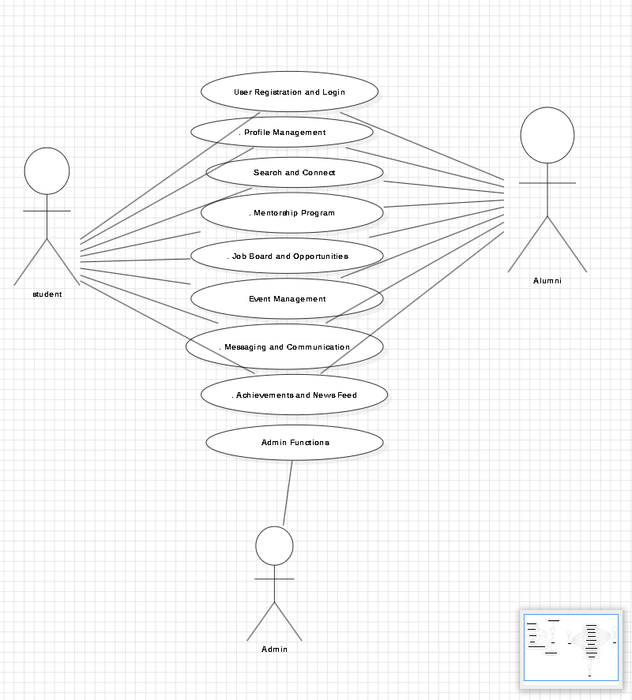

**3.4 System Functional Requirement Specification**

**3.4.1 User Registration and Authentication**

**3.4.1.1 User Registration**

* + The system shall allow students and alumni to register by providing required information such as name, email, password, and user type (student or alumni or company).
  + The system shall validate the user using two factor authentication
* **3.4.1.2User Login**
  + The system shall allow registered users to log in using their username and password.
* **3.4.1.3Password Reset**
  + The system shall provide a "Forgot Password" option that sends a password reset link to the user's registered email.
  + The system shall allow users to securely reset their passwords using the link provided.

**3.4.2 Profile Management**

**3.4.2.1 Create and Manage User Profiles**

* + The system shall allow users to create a profile upon successful registration, including personal information, educational background, and professional experience.

**3.4.2.2 Edit Profile Information**

* + The system shall allow users to update their profile information at any time, including adding new achievements or changing their profile picture.

**3.4.3 Messaging and Communication**

**3.4.3.1 Send and Receive Messages**

* + The system shall allow users to send and receive private messages to and from other users within the platform.
  + The system shall notify users of new messages through alerts or notifications.

**3.4.3.2 Events Chat**

* + The system shall allow users to participate in or create events chats with multiple users on shared topics or interests.

**3.4.3.3 Message History**

* + The system shall store and allow users to access past messages and chat history.

**3.4.4 Event Management**

**3.4.4.1 Event Calendar**

* + The system shall provide an event calendar where users can view upcoming networking events, workshops, and university activities.

**3.4.4.2 Register for Events**

* + The system shall allow users to register for events directly through the platform, with confirmation provided upon successful registration.

**3.4.4.3 Create and manage Events**

* + The system shall allow alumni and/or companies to create and manage events on the platform.

**3.4.5 Job Board**

**3.4.5.1 Post Job Opportunities**

* + The system shall allow companies to post job opportunities, including internship positions, full-time roles, and part-time jobs.
  + The system shall allow companies to include detailed job descriptions, requirements, and application deadlines.

**3.4.5.2 Search for Job Opportunities**

* + The system shall provide search functionality to help users find jobs with.

**3.4.5.3 Apply for Jobs**

* + When the user apply the system will redirect him/her to their personal email application and starts an email to company email address
  + The company should provide contact information to let the users apply for the work.

**3.4.6 Mentorship Program**

**3.4.6.1 Enroll as Mentor for alumni**

* + The system shall allow alumni to enroll as a mentor by clicking on the available button on his/her profile

**3.4.6.2 Mentorship selection**

* + The system shall match mentors(alumni) with students based on mentor(alumni) availability.

**3.4.6.3 Schedule Mentorship Sessions**

* + The system shall allow mentors and mentees to schedule mentorship sessions within the platform, including setting dates, times, and communication methods (video call, in-person).

**3.4.7 users Achievements and News Feed**

**3.4.7.1 Post Achievements**

* + The system shall allow users to post and share their professional or academic achievements with the community.

**3.4.7.2 View users News Feed**

* + The system shall provide a news feed that displays the user’s achievements, updates, and other relevant news.

**3.4.7.3 Engage with News Content**

* + The system shall allow users to like, comment, and share posts within the users’ news feed.

**3.4.8 User Connection Management**

**3.4.8.1 Send Connection Requests**

* + The system shall allow users to send connection requests to other users, similar to a friend request on social networking platforms.

**3.4.8.2 Accept or Reject Connection Requests**

* + The system shall allow users to accept or reject connection requests received from other users.

**3.4.8.3 View Connections List**

* + The system shall provide users with a list of their accepted connections, showing their profiles and allowing easy access to message or interacting with them.

**3.4.9 Administration and Moderation**

**3.4.9.1 Monitor Platform Usage and Analytics**

* + The system shall provide administrators with tools to monitor platform usage, including user activity, event participation, and content engagement.

**3.4.9.2 Manage Content**

* + The system shall allow administrators to manage and moderate user-generated content, including job posts, event listings, and news articles.

**3.5 Textual Description for Each Use Case**

1. **User Registration and Login**

* **Register as a New User**

Description: Alumni or students or company complete a registration form to create an account on the platform. The form collects necessary details like name, email, and password. Once the information is validated, the system creates a new account.

* **Log in to the System**

Description: Alumni or students or company must log in by entering their username and password.

* **Reset Password**

Description: Alumni or students or company who forget their password can request a password reset. The system sends a reset link or code to the registered email. The user follows the link or enters the code to set a new password.

**2. Profile Management**

* **View Profile**

Description: Alumni or students or company can view their own profile or the profile of another user. The system displays details such as personal information, educational background, and professional experience.

* **Edit Profile Details**

Description: Alumni or students or company modify specific sections of their profile, including personal details, educational background, or professional experience, phone number and email address . The system updates the profile with these changes.

**3. Search and Connect**

* **Search for Other Users**

Description: Alumni or students use the platform’s search functionality to find other users based on various criteria such as name, educational background, professional experience, or location.

* **Send Connection Requests**

Description: Alumni or students send a request to connect with another user on the platform. The system notifies the request and waits for their response.

* **Accept or Reject Connection Requests**

Description: The recipient of a connection request can choose to accept or reject it. The system updates the connection status based on the recipient’s decision and notifies both parties.

* **View Connections List**

Description: Alumni or students view a list of their accepted connections, which includes other users they are connected with. The system displays this list with relevant details**.**

**4. Mentorship Program**

* **Enroll as Mentor(alumni)**

Description: Alumni or students enroll in the mentorship program by indicating mentor(alumni) availability and student can select the suitable mentor.

* **Search for Mentors**

Description: students search for potential mentors using mentor availability. The system returns a list of users that match the search criteria.

* **Starting mentorship**

Description: when the student select the mentor(alumni) ,the system will redirect the student to the mentor(alumni) profile so they can start chatting

**5. Job Board and Opportunities**

* **Post Job Opportunities**

Description: companies can post job opportunities, including details such as job title, description, and application instructions. The system publishes this listing for other users to view.

* **Search for Job Opportunities**

Description: Alumni or students search for job openings .The system displays a list of all of the job postings.

**6. Event Management**

* **View Upcoming Events**

Description: users can view a list of upcoming events hosted by the platform, including details such as event dates, times, and descriptions. The system provides this information for users to explore and plan their attendance.

* **Register for Events**

Description: users can register to attend an upcoming event by clicking on register button. The system confirms the registration and updates the event’s attendee list and redirect the participant to the event’s chat.

* **Create or Manage Events**

Description: Alumni or students or company create new events or manage existing ones.

**7. Messaging and Communication**

* **Send and Receive Messages**

Description: Alumni or students send and receive messages through the platform’s messaging system. The system ensures that messages are delivered and stored securely.

* **Participate in general Chat**

Description: Alumni or students join and participate in general chats with other users. The system facilitates real-time communication within the chat groups.

**8. Achievements and News Feed**

* **Post Achievements**

Description: users can post updates about their professional or academic achievements. The system displays these posts on their profile and in relevant feeds.

* **View Alumni Achievements and News**

Description: users can view recent achievements and news posted by other alumni. The system displays this information on the alumni news feed.

**9. Admin Functions**

* **Monitor Platform Usage and Analytics**

Description: An administrator reviews statistics and analytics related to platform usage to monitor alumni and student activity, engagement, and overall performance. The system generates and provides reports and insights.

* **Manage Content (Job Posts, Events, News Articles)**

Description: An administrator manages content on the platform, including job postings, event details, and news articles. The system allows the administrator to create, edit, and remove content as needed.

**3.6 Non-Functional Requirements**

**3.6.1 Performance Requirements**

* **Response Time**: The platform must respond to user actions, such as loading profiles or sending messages, within 2 seconds under normal operating conditions.
* **Scalability**: The platform should be able to handle up to 100 users at the same time without slowing down or having any issues with performance.

**3.6.2 Dependability Requirements**

* **Uptime:** The platform should be available and working at least 99.9% of the time, so users can access it almost all the time.
* **Data Backup**: User data, including profiles, messages, and event registrations, must be backed up every month to prevent data loss.
* **Error Handling**: The platform must detect and log errors automatically and provide users with meaningful error messages, without crashing.

**3.6.3 Security Requirements**

* **Data Encryption:** All sensitive data, like personal information and messages, must be protected by encryption while it's being sent and stored, using widely accepted security standards
* **Authentication**: The platform must implement secure authentication methods, such as two-factor authentication (2FA), to verify user identity.
* **Access Control:** The platform should have different permission levels to make sure that only authorized users can see or change important information, like settings or profiles.

**3.6.4 Usability Requirements**

* **Ease of Use**: The platform should be easy to use, so users can do things like update profiles or send messages quickly and without needing much help or instructions.
* **Accessibility:** The website should be accessible from all platforms and must run smoothly on the of them.
* **User Feedback**: The platform should include a feature that allows users to easily submit feedback or report issues.

**3.6.5 Operational and Environmental Requirements**

* Integration with Existing Systems: Compatibility with existing university databases.
* Provide help documentation and support.
* Optimize server energy consumption to minimize environmental impact.

**3.6.6 Maintainability Requirements**

* **Code Modularity**: The platform’s codebase should be modular, allowing for easy updates and modifications without affecting the entire system.
* **Documentation**: Comprehensive technical documentation must be maintained to facilitate future maintenance and development.
* **Update Process**: The platform should allow for smooth updates and patches with minimal downtime, ideally less than 5 minutes during off-peak hours

**3.7 Data Requirements**

**3.7.1 User Profiles Data**

**Required Information**:

* + Personal information (name, email, phone number)
  + Bio(Educational background (degrees, majors, graduation year), Professional experience (job titles, companies, years of experience))
  + Profile pictures
  + Skills and interests

**3.7.2 Messaging and Chat Data**

* + Message content (text)
  + Sender and recipient identifiers
  + Timestamps (date and time of messages)

**3.7.3 Event Calendar Data**

* + Event details (name, date, time)
  + Event descriptions
  + Host information (organizer's name and contact)
  + Registration data (list of attendees).

**3.7.4 Job Board Data**

* + Job postings (job title, company, location)
  + Job descriptions and requirements
  + Employer contact information

**3.7.5Mentorship Program Data**

* + Mentor and student profiles
  + Mentorship preferences (availability)

**3.7.6 users Achievements and News Data**

* + users’ achievements (awards, publications, promotions)
  + University news (announcements, updates)
  + Related media (photos, videos, articles)

**3.7.7 Security and Privacy Data**

* + User credentials (usernames, passwords)
  + Authentication logs (login attempts, IP addresses)
  + Data encryption and privacy settings

**3.7.8Analytics and Reporting Data**

* + User engagement metrics (logins, active users, session duration)
  + Event participation statistics
  + Job application tracking

**4.0** **Analysis and Design**

**4.2 Sequence Diagrams**

**4.2.1 Student Sequence Diagrams**

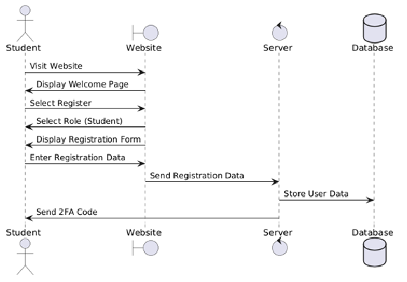

Registration

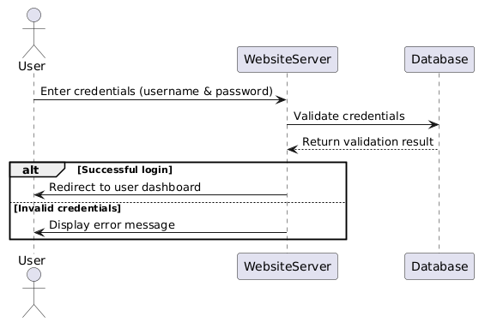

Login

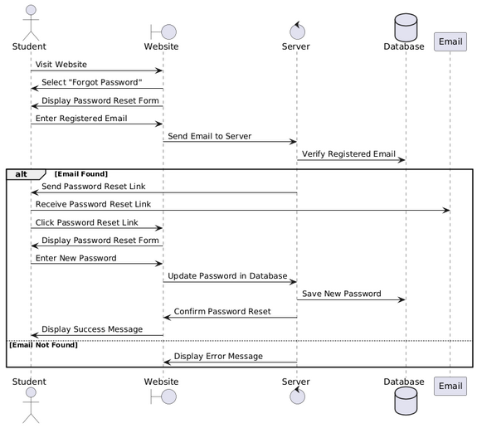

Password recovery

Profile management

Chat

Events

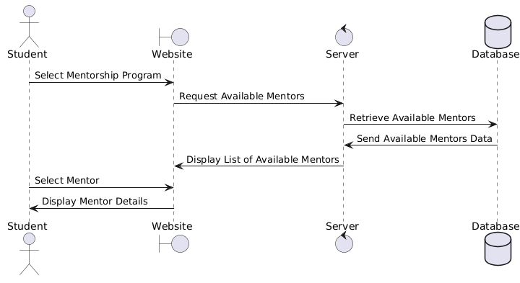

Mentorship

Make connections

Applying for jobs

Newsletter and achievements

**4.2.2 Alumni Sequence Diagrams**

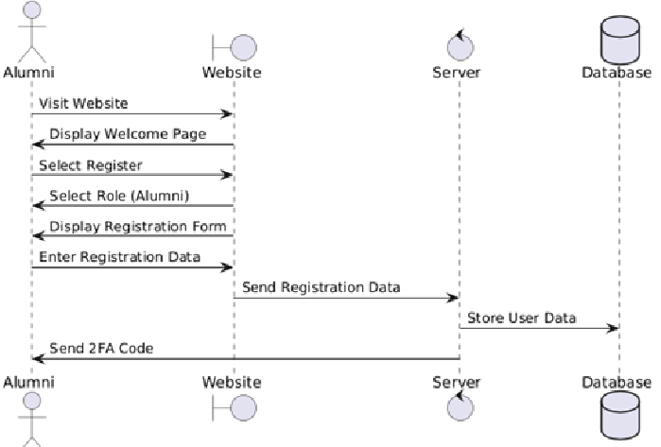

Registration

Login

Password recovery

Profile management

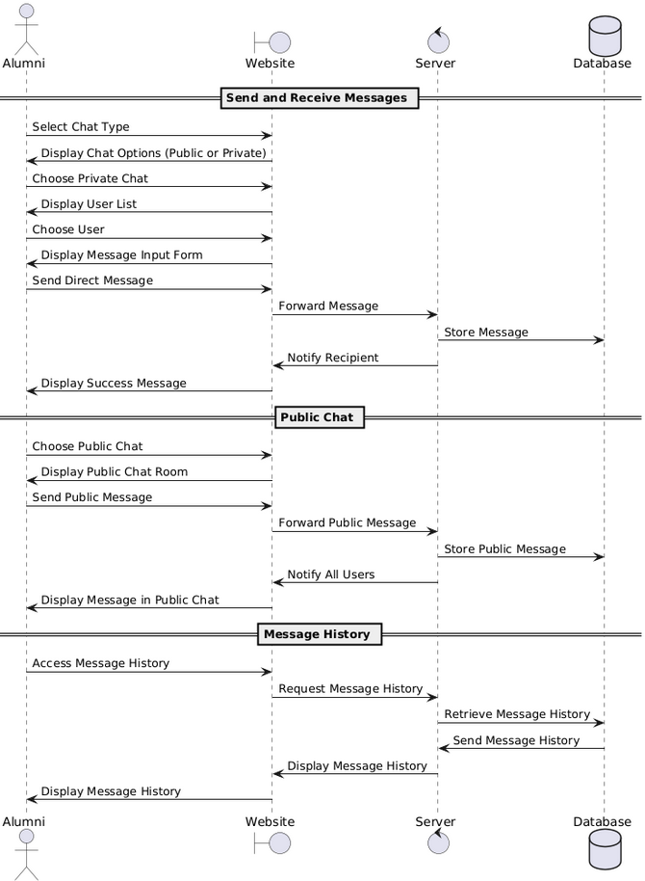

Private chat

Messaging

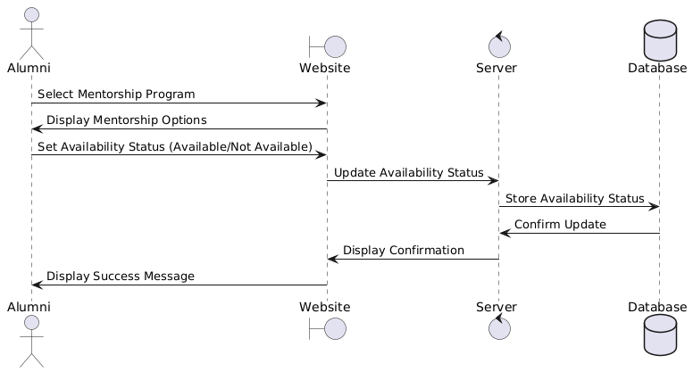

Mentorship

Events

Job board

Newsletter and achievements

Make connections

**4.2.3 Company Sequence Diagram**

Registration

Login

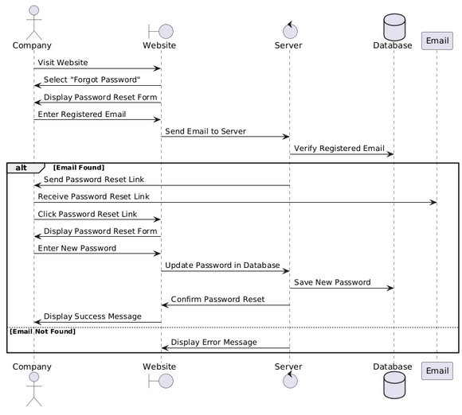

Password recovery

Profile Management

Events chat

Messaging

Events

Posting job opportunities

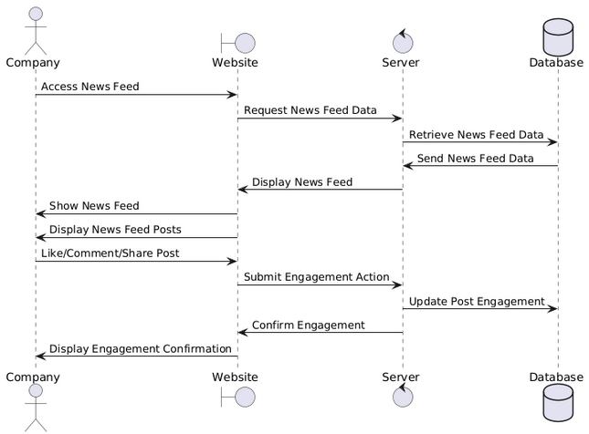

Newsletter and achievements

**4.2.4 Admin Sequence Diagram**

Monitor Platform Usage and Analytics

Manage Content

**4.3 Class Diagram**

**4.3.1 Component Diagram**

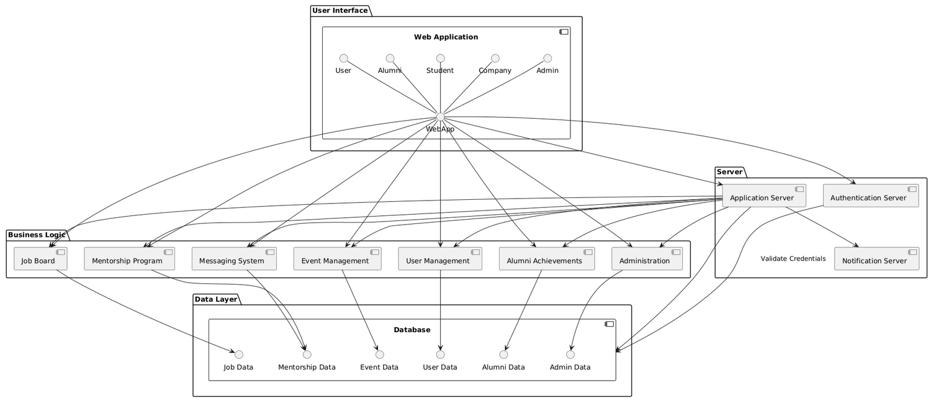

**4.3.2 Deployment Diagram**

**4.3.3 Data Flow Diagram**

**5.0 Implementation**

**5.1 Graphical User Interface Implementation**

* 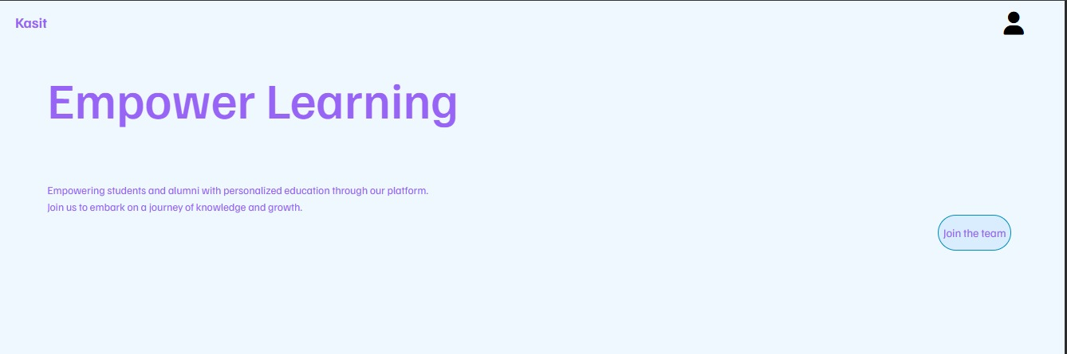**Welcome page: brief description about our website**
* **login page**: if you already have an account just type your username and password and check the “I’m not a robot” button then click Log In

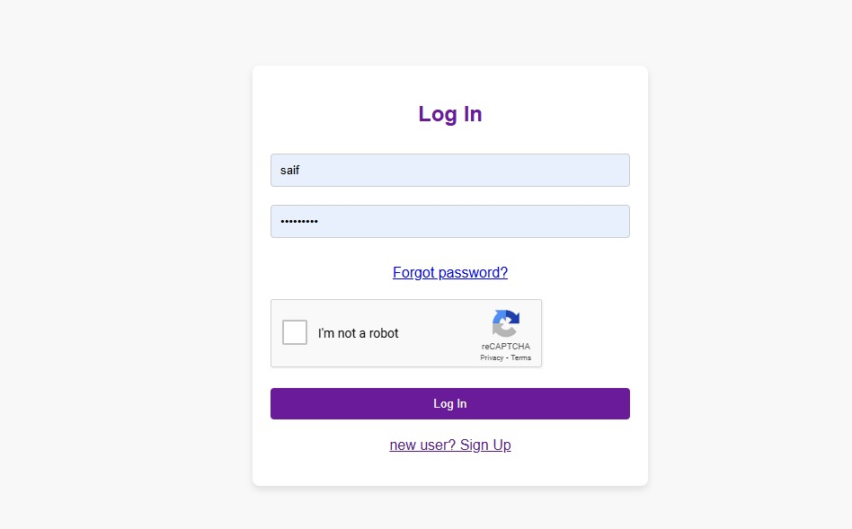if you don’t remember your password you have to click on Forgot password button that will lead you to Forgot password page

* **Signup page:** if you are new you need to choose a username, personal email and password (with consideration the note) then you need to rewrite your password then you need to choose (student || alumni || company) then you have to click on “I agree to the privacy policy” then click submit

* **2fa code generation page:** this page will generate a 16char code that you need to type it on your google authenticator application then click Next that will redirect you to login page

* 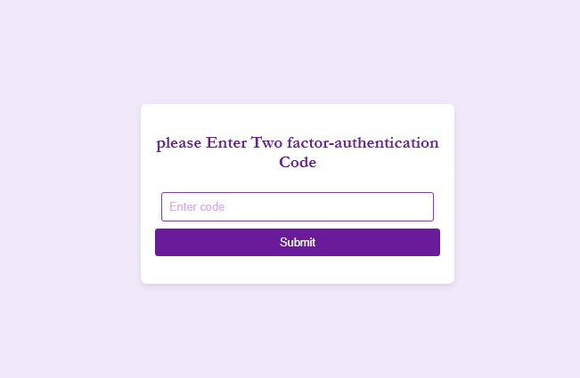**2fa page :**after login you need to put your code that you have received from google authenticator app
* 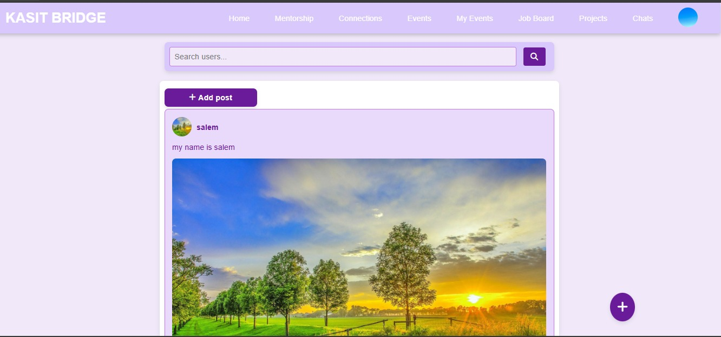**Home page:** you can post an acheivements and see others’ posts like, comment , share them
* **Create posts page:** from this page you can create a post and share it with others

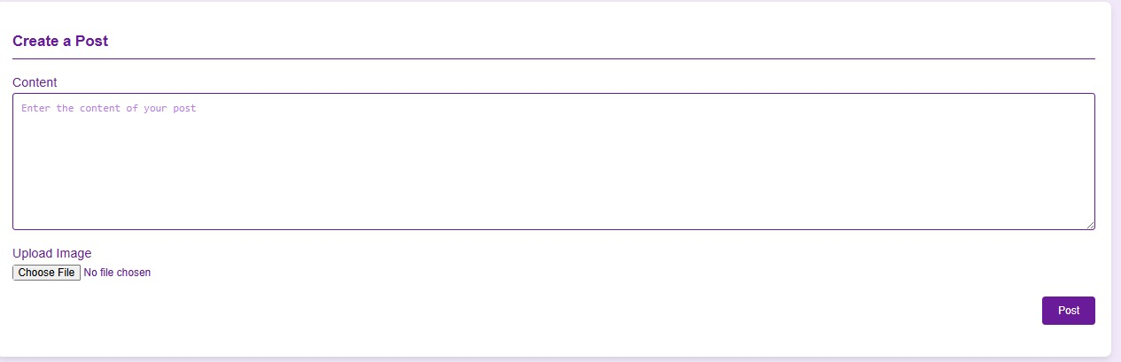

* 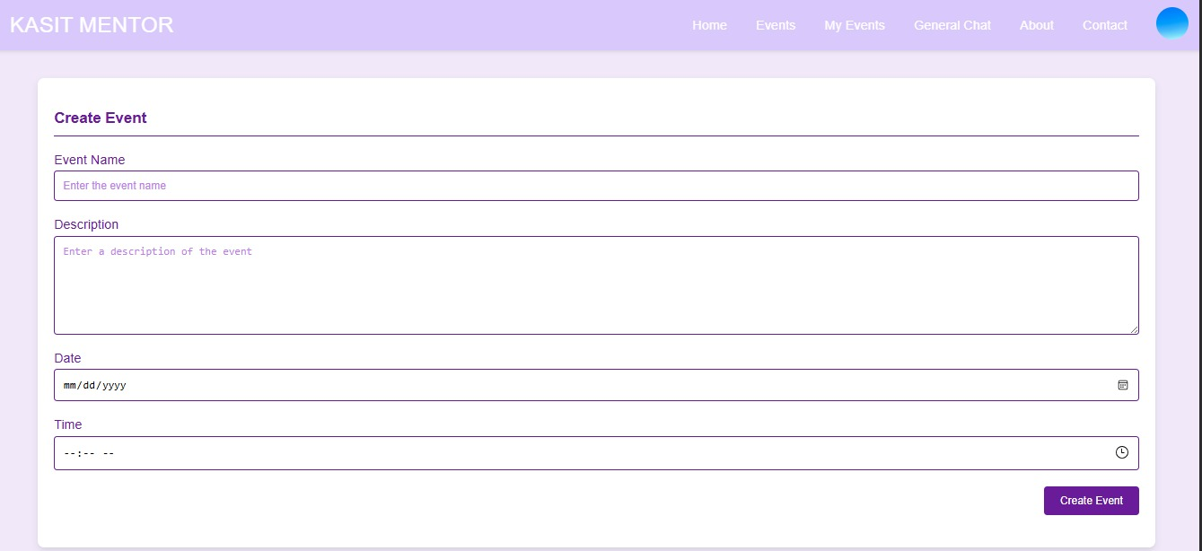**Create events page:** from this page you can create events by typing event
* **A screenshot of a computer

  Description automatically generatedEvents page:** contains all events and their description also you can register in any event you like
* 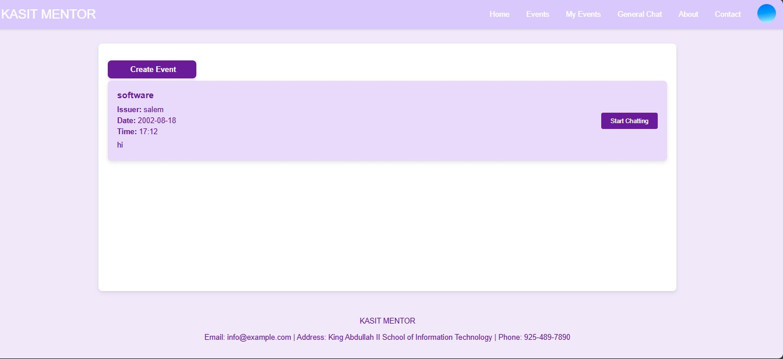**My events page:** you can see your registered events and you can join event chat
* **A person using a computer

  Description automatically generatedContact page:** if you have any questions on assistance, you can send a message
* 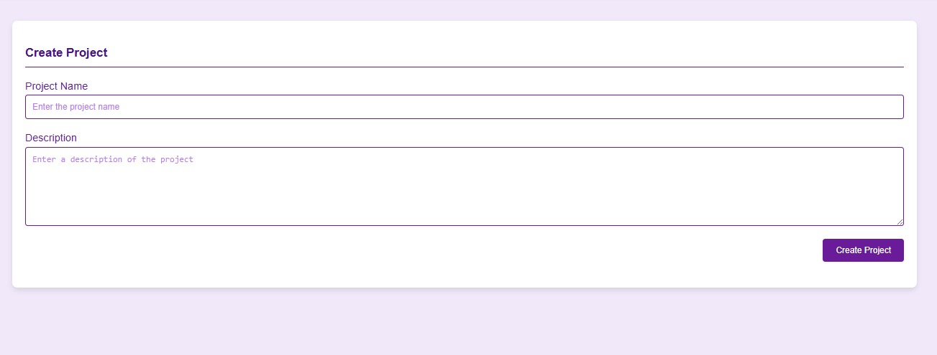**Create project** :if you need help on a project or you need team for a project also you need to type communication method in the description
* **A screenshot of a project

  Description automatically generatedProjects page:** at this page you can see the projects and their description if you are interested in any of them you can contact the project owner
* **User profile :**this page will show you your personal information like: first and last name, about, email, phone number, your posts, CV

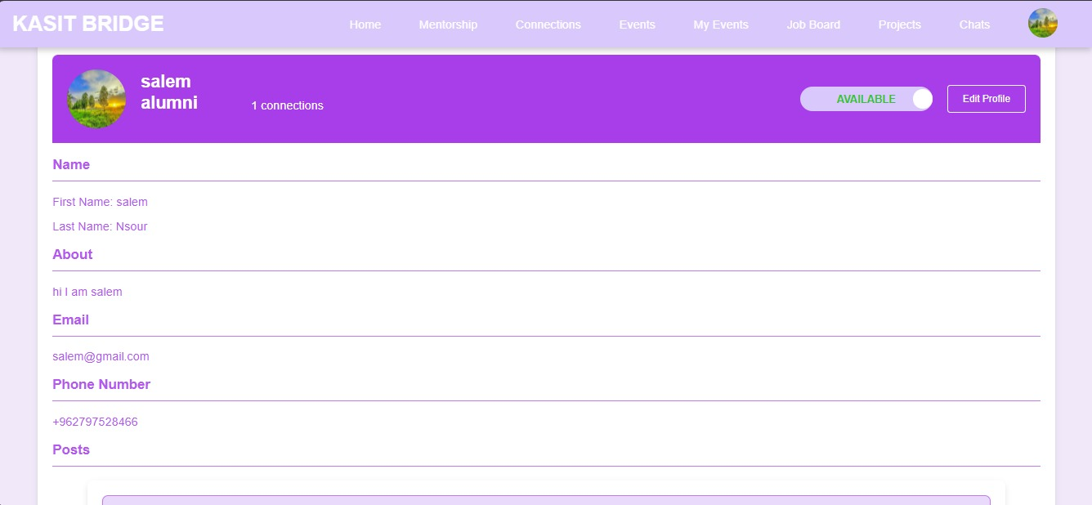

* **A black and white lines

  Description automatically generatedEdit profile : you can edit all of your personal information**
* **General chat :** every registered user can send messages on this chat so if you have any questions, you can ask for it

* 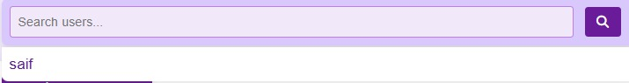**Search feature:**From home page you can search for users by typing their name or part of it then you can click on his/her name that will redirect you to his/her profile
* **From his/her profile you can click on “start chatting” to open a private chat between you and him/her**

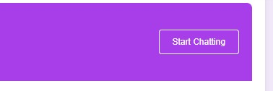

* **Private chat page**

* **Chats page:** here you can see all of your private chat also your events chats

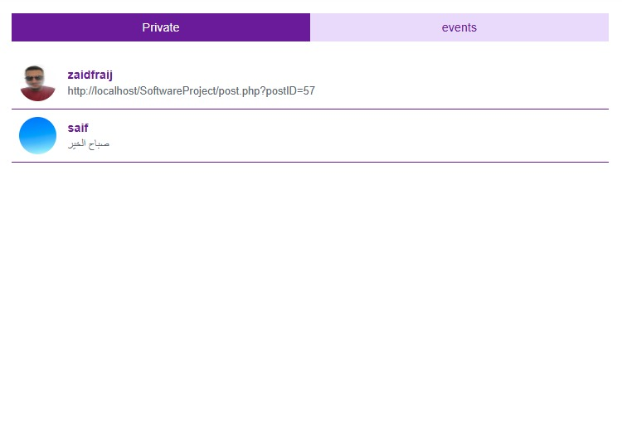

* **A screenshot of a computer

  Description automatically generatedMentorship program: if any student wanted a guidance he/she can go to this page and clicks on the suitable mentor and the website will redirect the student to mentor(alumni) profile page to start chatting**
* 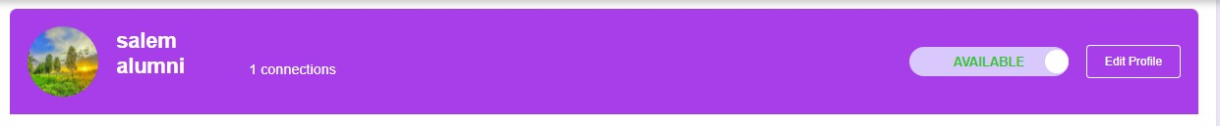**If you are an alumni and you want to mentor students you should go to your profile and swap your status to available in order to appear in mentorship page**

* 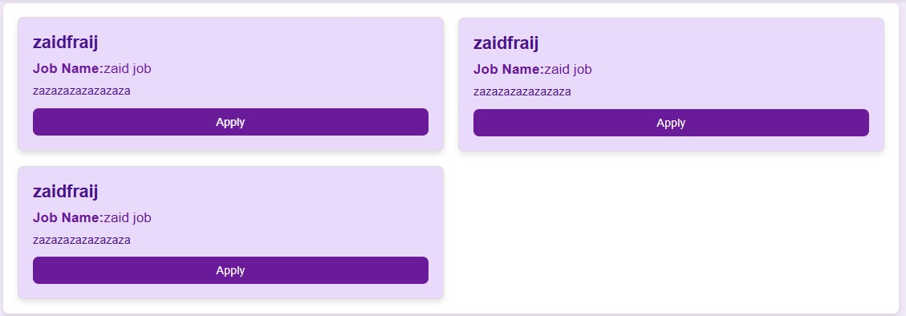**Job board:** alumni and students can apply for internship or a job using this page that will redirect them to their email in order to send email to the job posting company

* **A white sheet with black lines

  Description automatically generatedPosting jobs:** only companies can post jobs opportunities
* **Connection management page**

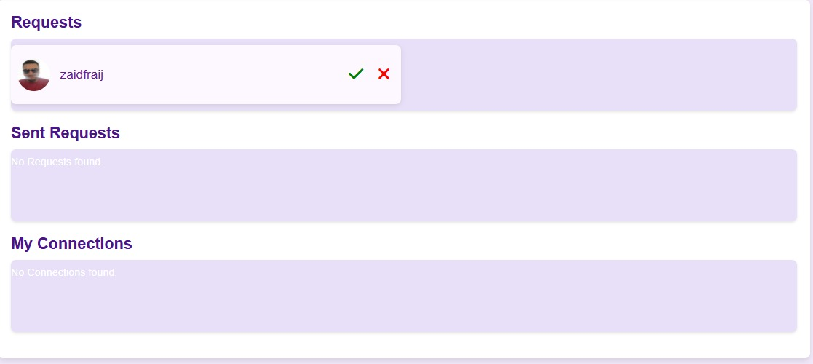

* **See your connections number**

* **Helpful YouTube videos links**

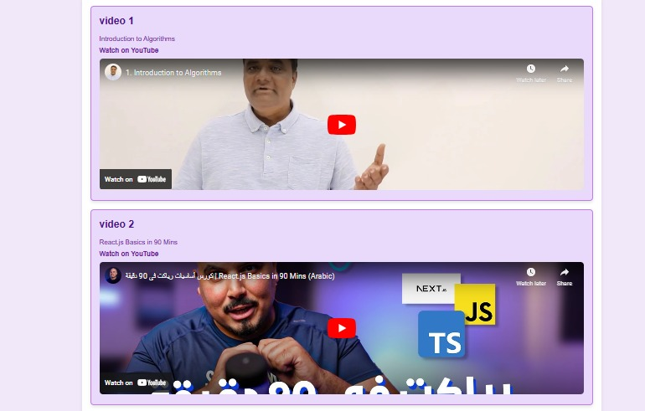

* **Successful stories: sharing some success stories to inspire the visitors**

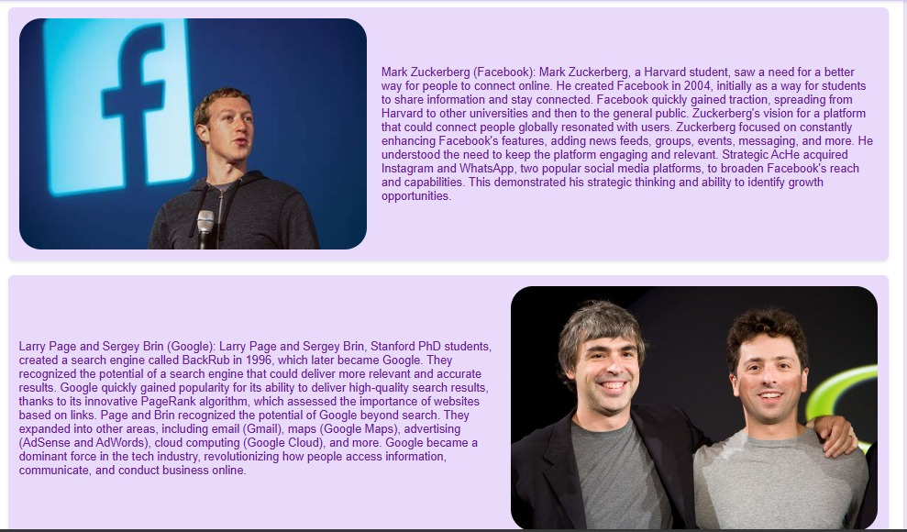

**5.2**

**Database Implementation**

**Database configuration**

**Database tables:**

**Events table**

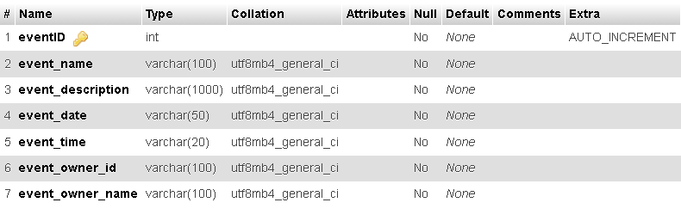

**Events_Chat table**

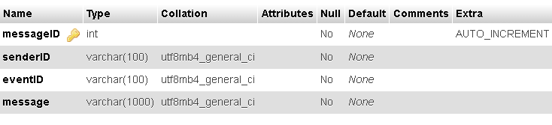

**Events registration table**

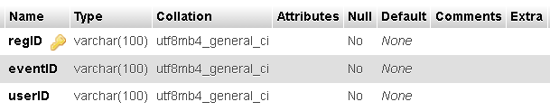

**general chat table**

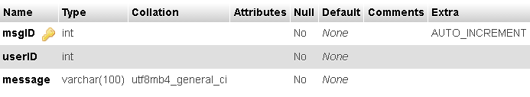

**Private chat table**

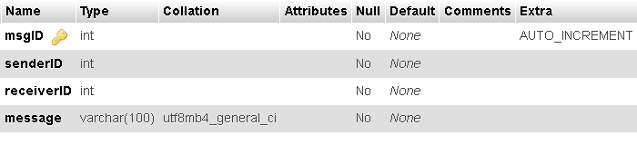

**Password token table**

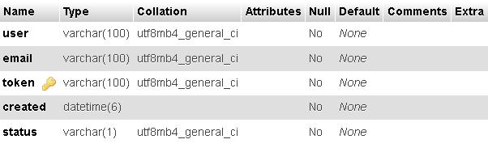

**Posts table**

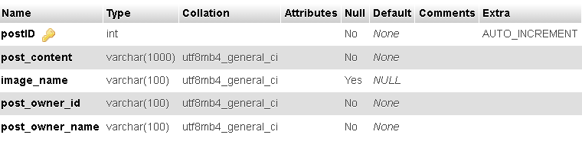

**Post comment  
**

**Jobs table**

**Users table**

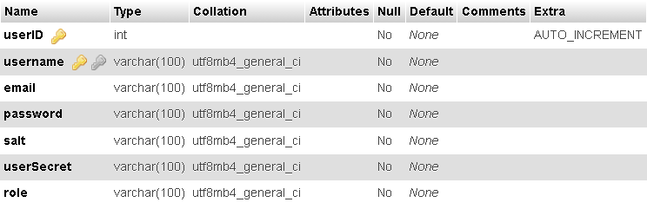

**Users’ information table**

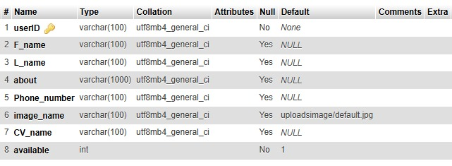

**Projects table**

**Contact table**

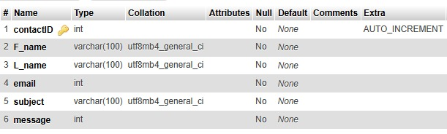

**Connection table**

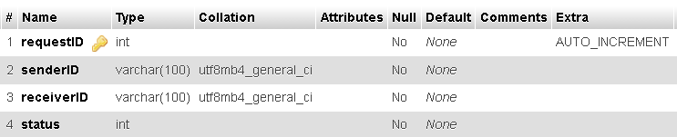

**5.3 backend Implementation**

* 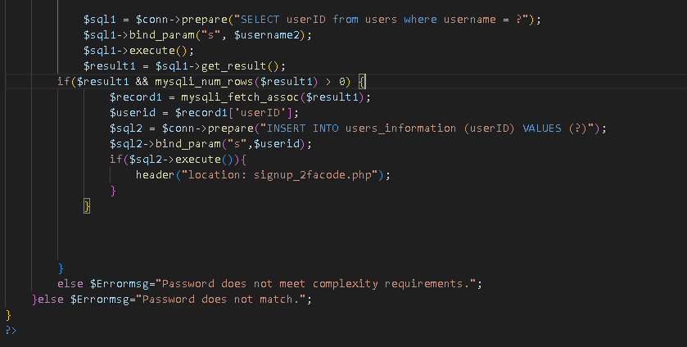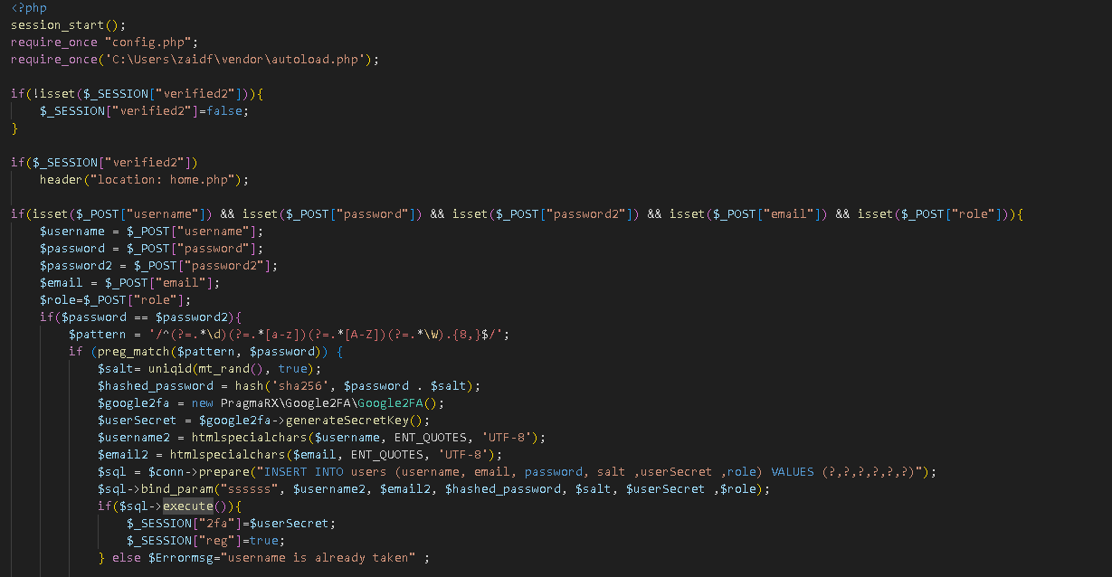**Signup page**
* A screenshot of a computer program

  Description automatically generated**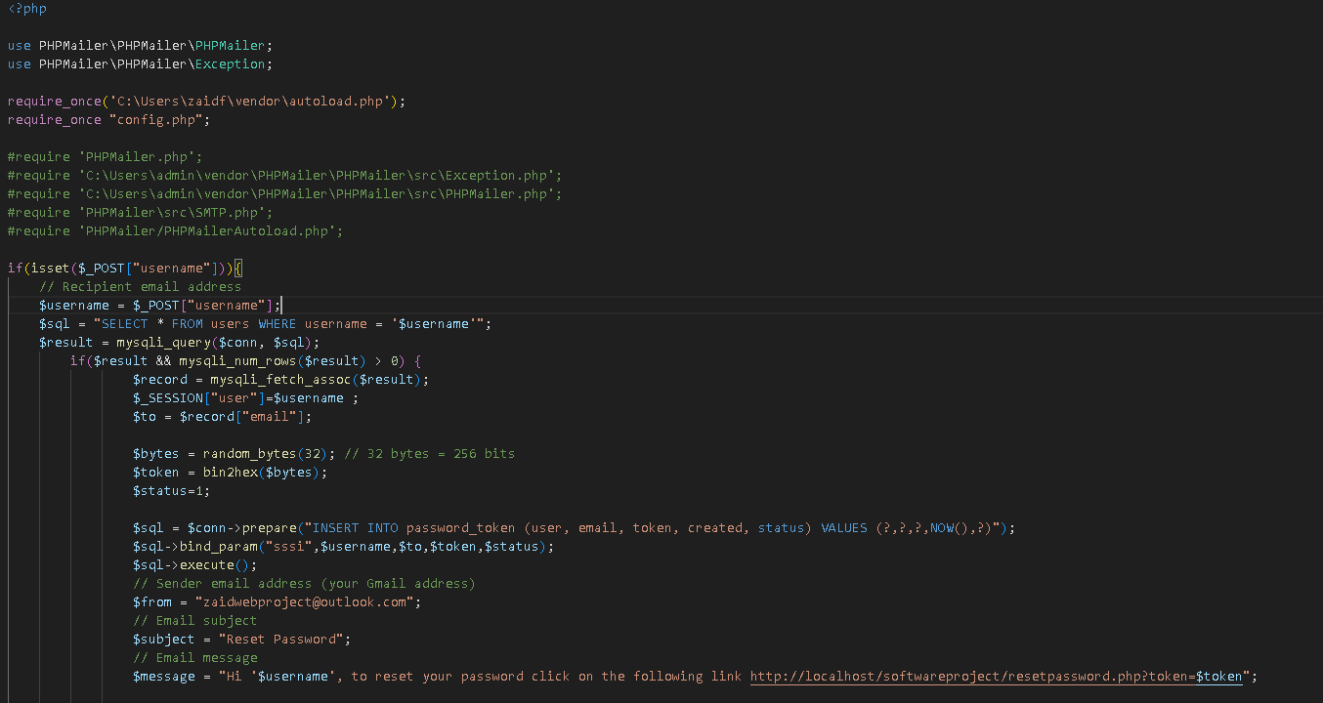Forget password**
* 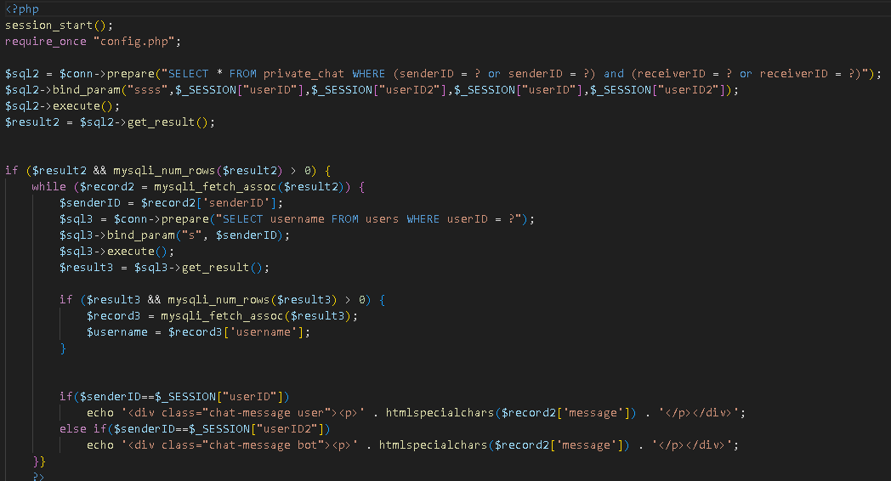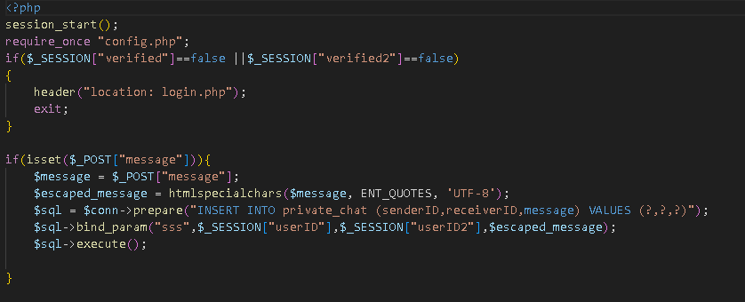**Private chat**
* **A screen shot of a computer program

  Description automatically generated2f code to type at google authenticator**



* 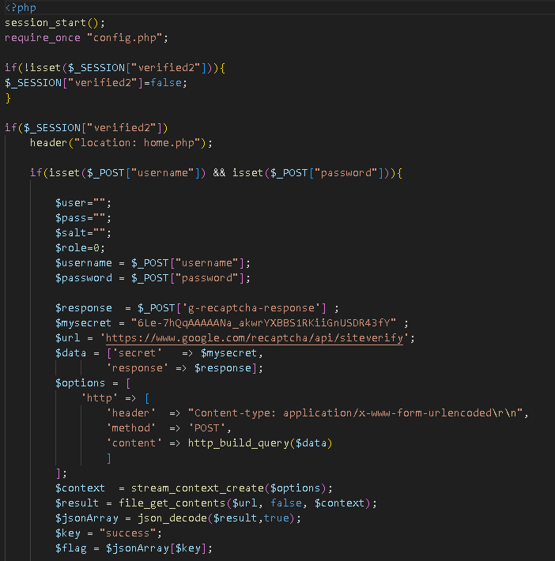**Login page**

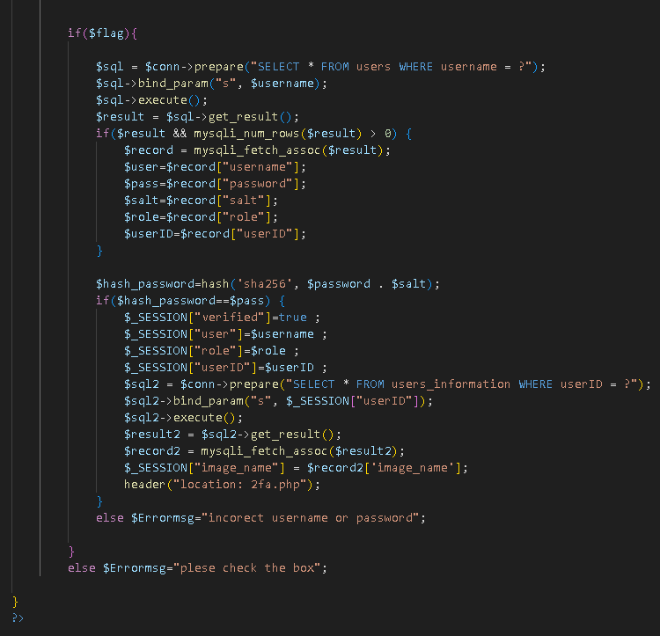

* 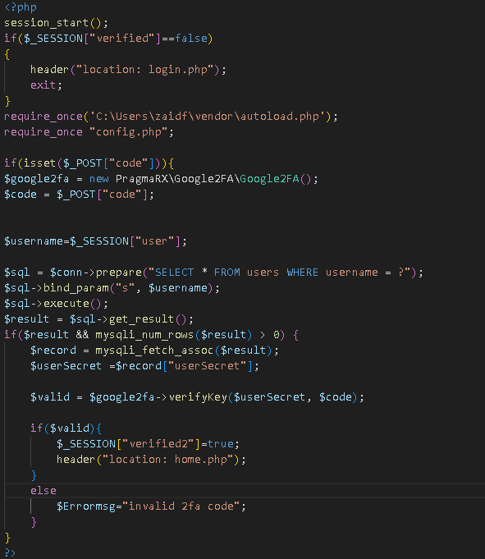**2fa page**
* **Home page**

**Search Feature**

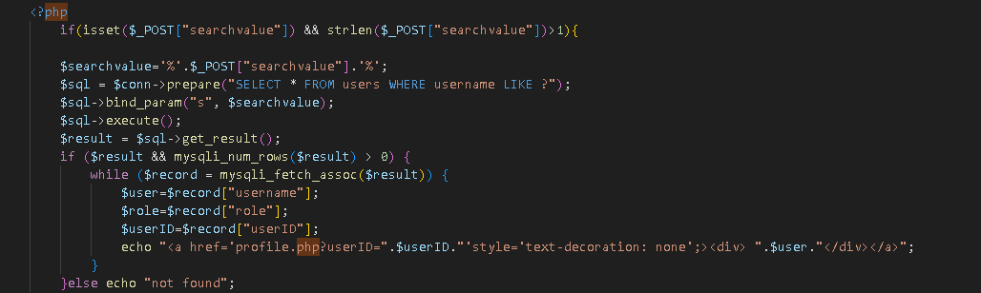

* **User ProfileA screen shot of a computer program

  Description automatically generatedA screenshot of a computer program

  Description automatically generated**

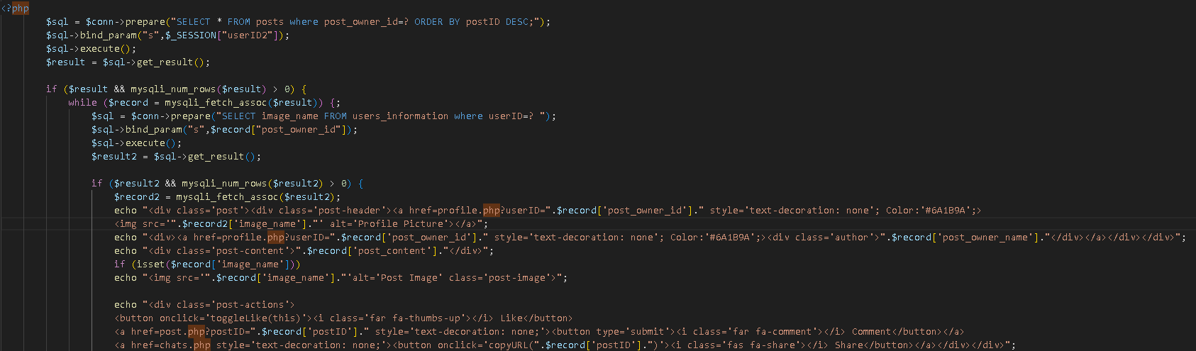

* **Edit profile**

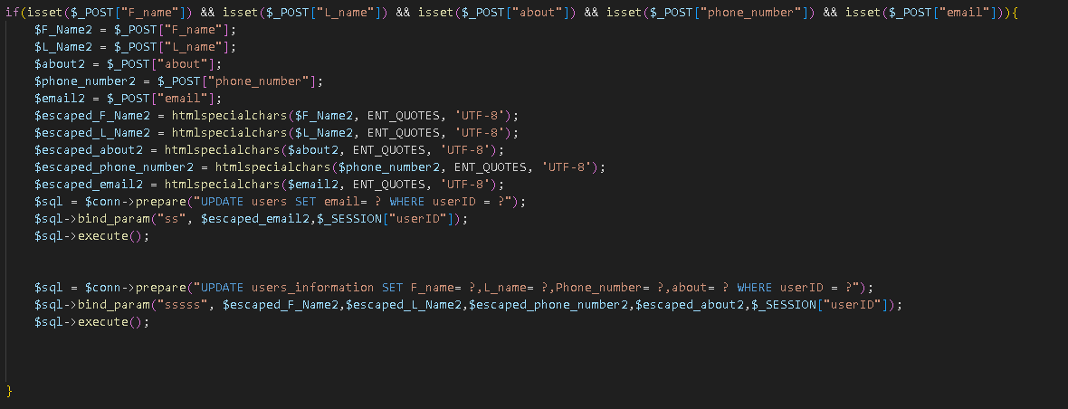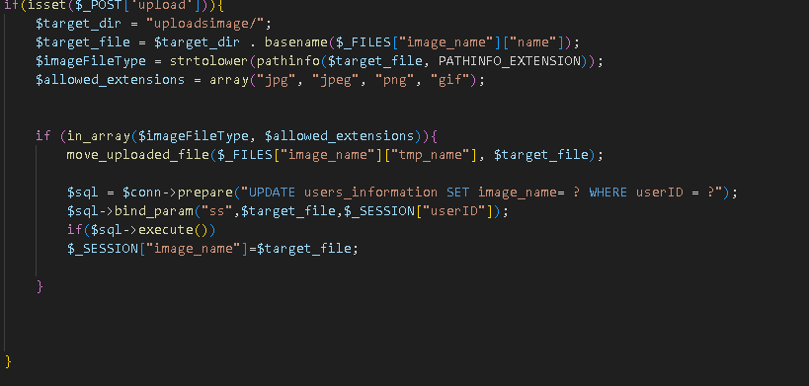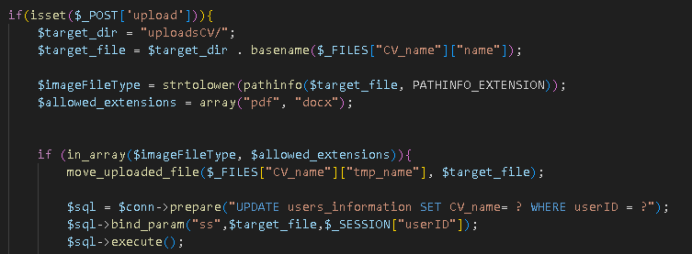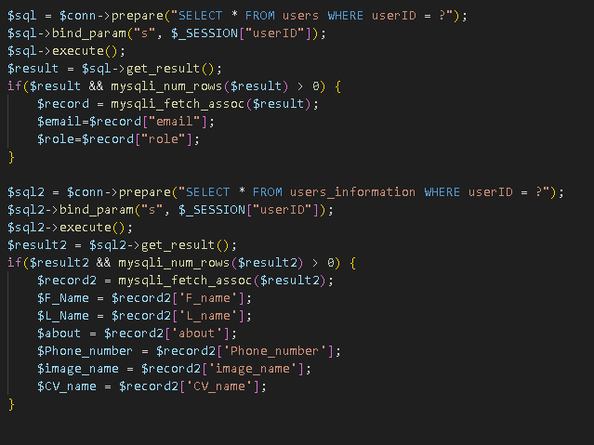

* **Reset password**

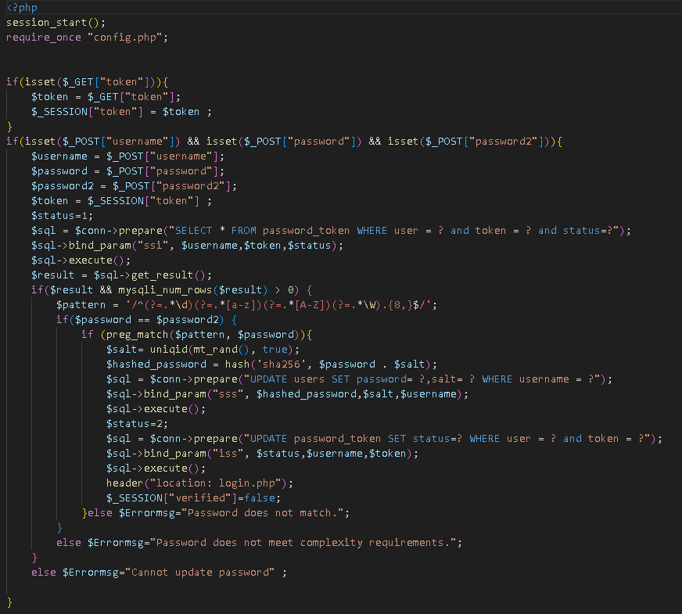

* **General chat**

* **Show your messages(private and events)**

**Private messages**

* 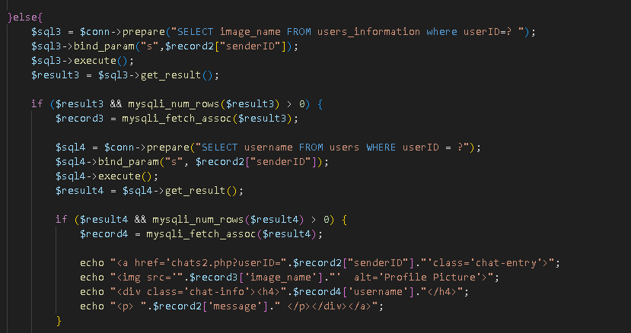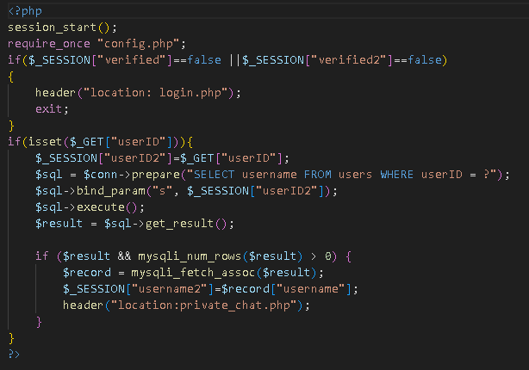

**Your events’ chats**

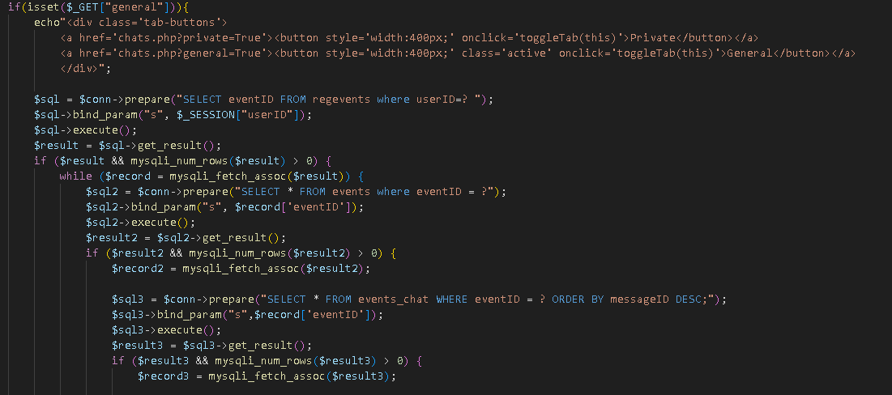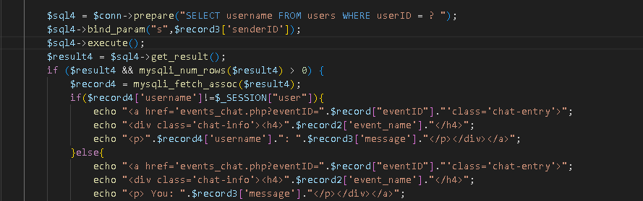

* **Create post**

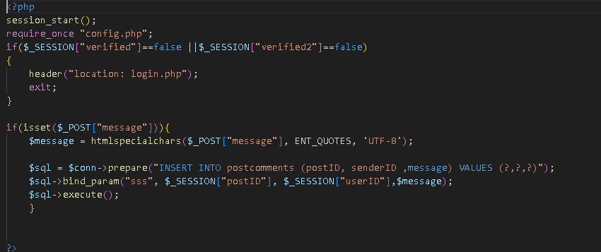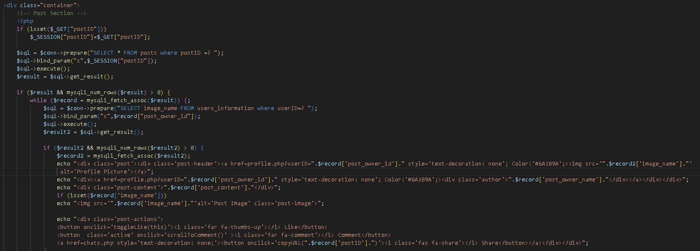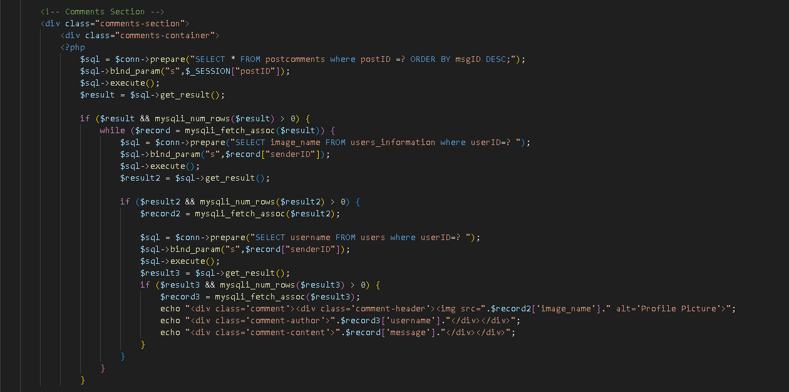

* **Create events page (for alumni and company)**

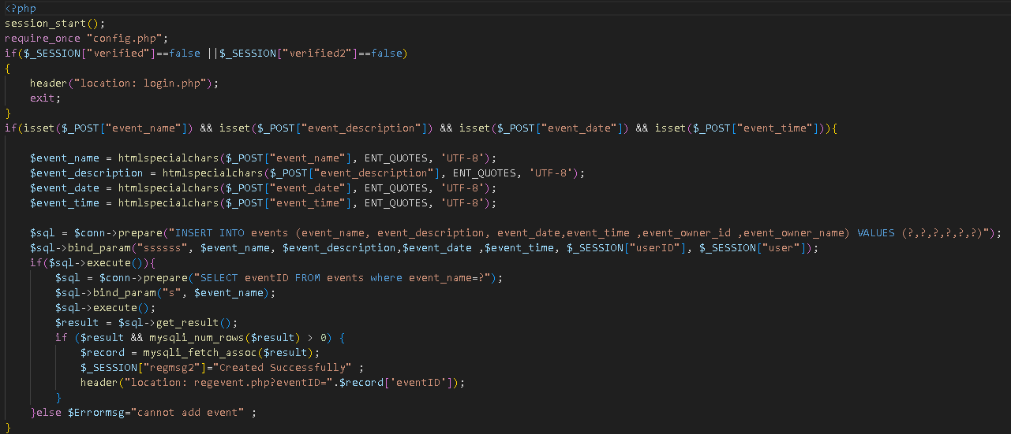

* **Events page**

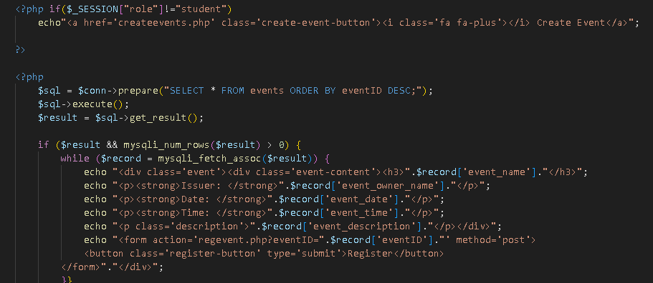

* **My events page**

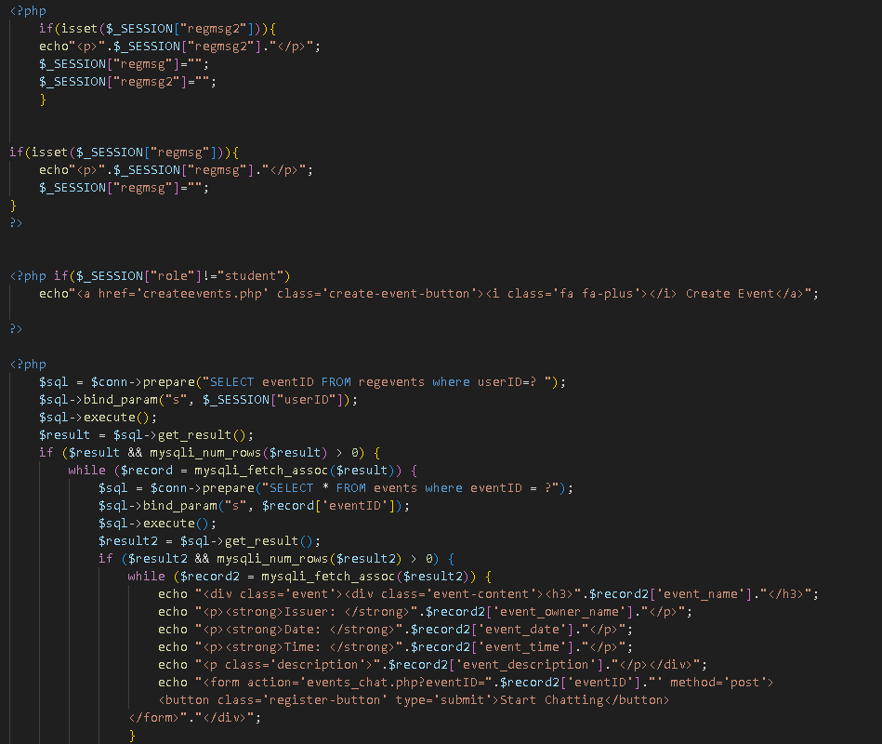

* **Event chat page**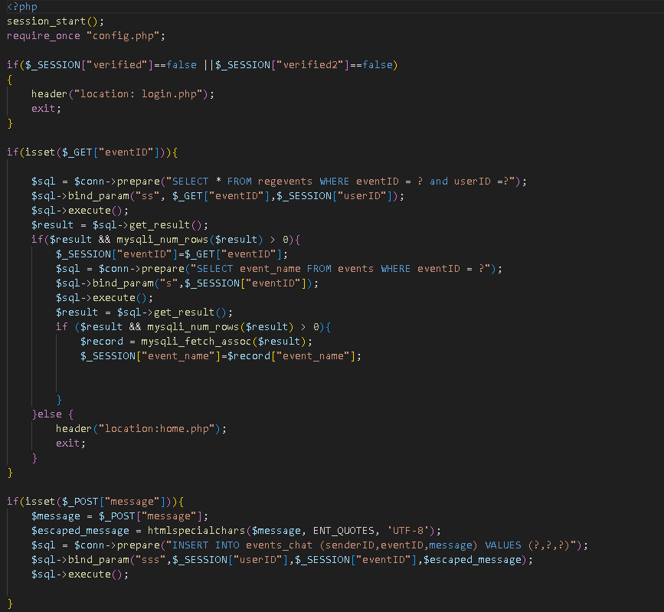
* **Event registration page**

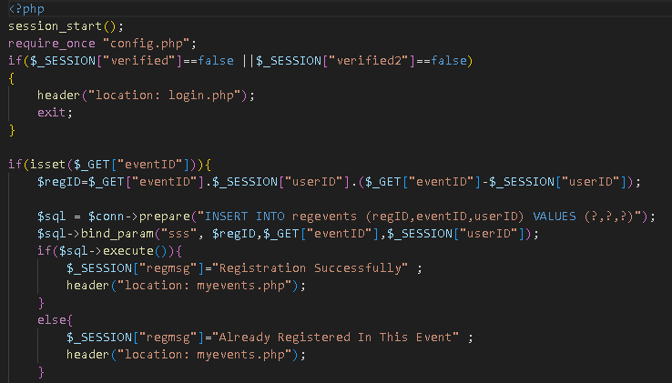

* **Add project**

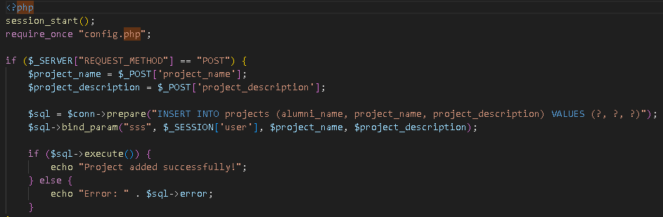

* **View project**

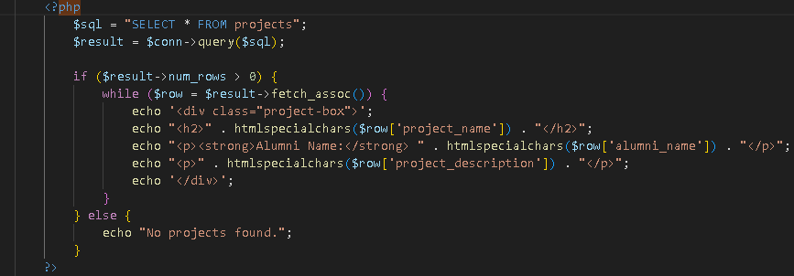

* **Show available alumni page**

* **Available or not functionality (from profile)**

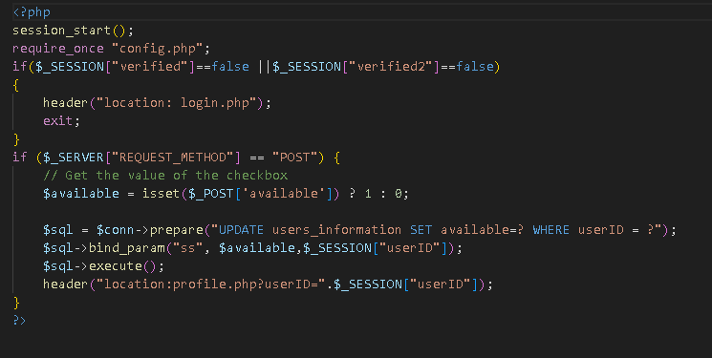

* **Create job (for companies only)**

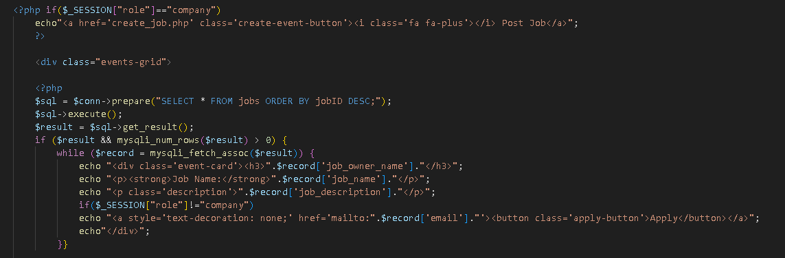

* **Show available jobs**

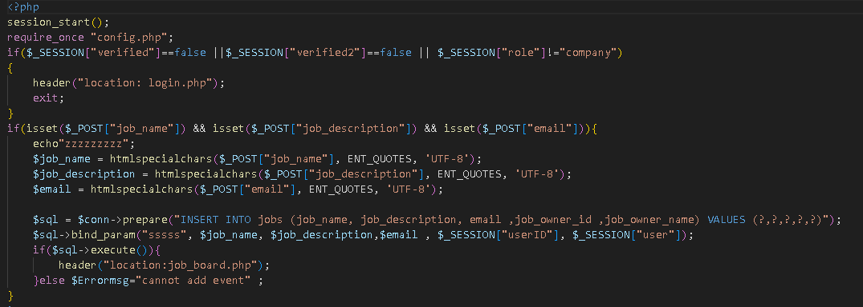

* **Connection feature**

**requests**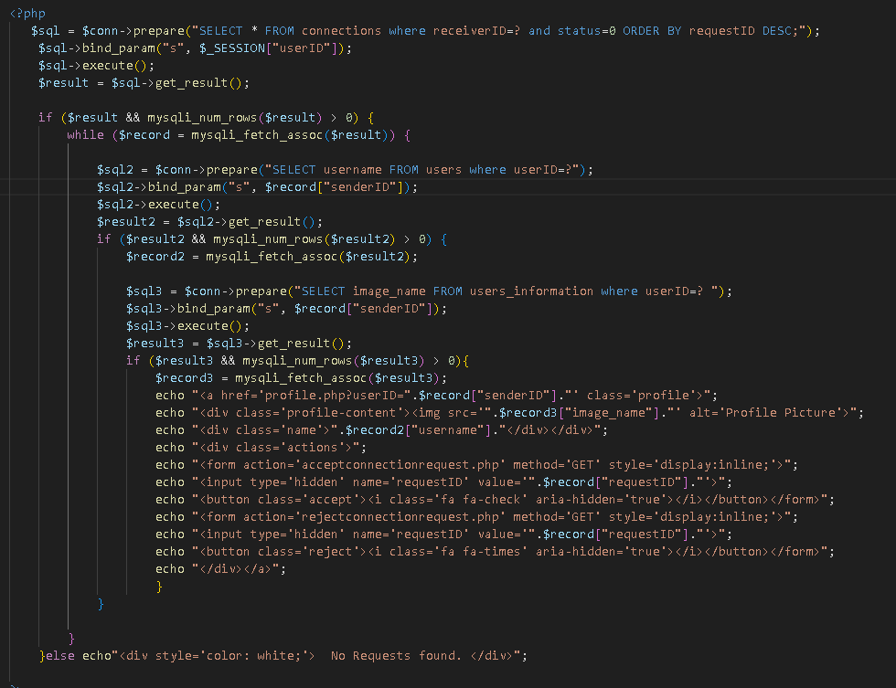

**Sent Requests**

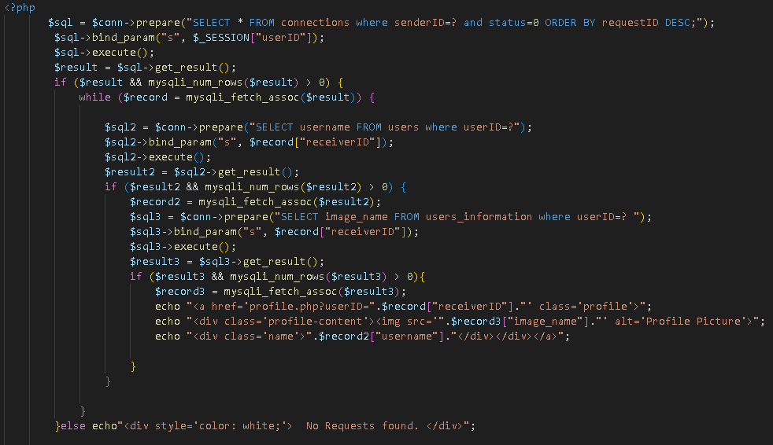

**My Connections**

**Accept connection**

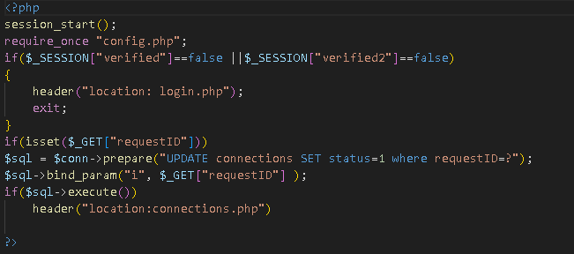

**Reject connection**

* **Logout page**

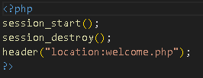

**6.0 User Manual**

**1)Visit our website : localhost/soft/welcome.php**

**2)From welcome page click on the top right figure that will redirect you to login page.**

**3)If you have an account enter your credentials(username, password, reCAPTCHA button) then click login and enter 2fa code received on your google authenticator app.**

**If you don’t have account, click on sign up link, it will redirect you to signup page , enter a username ,email , password and choose your role(student, alumni ,company ) then click on “I agree to the privacy policy ” then click on submit then take the code and put it in your google authenticator app that will give you a code after you login .**

**4)If you have an account but you have forgotten your password you can click on forgot password then you type your username and you will receive a link on your email to reset your password.**

**4)After logging in you will be at the home page that from it you can :**

* **search for users from search bar :after searching if you click on his/her name, you will see their profile and from there you can start chatting with them.**
* **see other posts, you can like , comment , share them .**
* **you can also post an achievement or a news report.**

**5)If you click on the top right corner, you can see your profile ,general chat ,learning page ,successful stories , contact and you can log out.**

**6)In your profile you can see your personal information , and if you click on edit profile , you edit your personal info .**

**7)from home page if you look at the top of the page you can see:**

* **events :**you can the available events and you can register in any event you like ,if you click on register it will be in my events page also you can access the event that you have registered chat to know further details .
* **create event:** if you are an alumni or a company you can create an event in order to share knowledge or meetup with new people .
* **my events:** on this page you will see your registered events and your events that you have created recently .
* **add project:** if you need some help in a project or you need a team for a project ,you can announce that using this page and you have to choose communication method .
* **view projects**: if you want to work on a project or you want to help someone on their projects ,you can contact them and help them .
* **job board :** if you are a company, you can add a job or internship but if you are a student or alumni can only apply for jobs and internship .
* **general chat(top right features) :**a chat that everyone can access and send messages .
* **contact :**if you have any questions or you need any assistance you can send a message to us .
* **successful stories(top right features) :** in this page you will see some success stories that have changed the world into better that can inspire you to do something like that in the future.
* **Helpful link(top right features) :** in this page you can find some helpful videos that can add some knowledge to yours and help you in your learning progress

8) if you are a mentor and you want to help some student you can go your profile and change your status into available and you will appear in the mentorship page so the students can come and ask you questions or if they need some guidance.

If you are a student ,you can simply go to the mentorship page and select a mentor and ask him/her whatever you want .

9) connection feature : if you want to connect with someone, you can simply go to their profile and click on connect button that will send a connection request to him/her, and he/she will receive the request and he/she can either accept or reject the request

**7.0 References: books and tools**

<https://www.techsmith.com/blog/user-documentation/>

<https://chatgpt.com/>

<https://www.wikipedia.org/>

<https://gemini.google.com/>

Software Engineering” by Ian Sommerville (Our material in the university).